**Half Adder Verilog code through behavior model:**

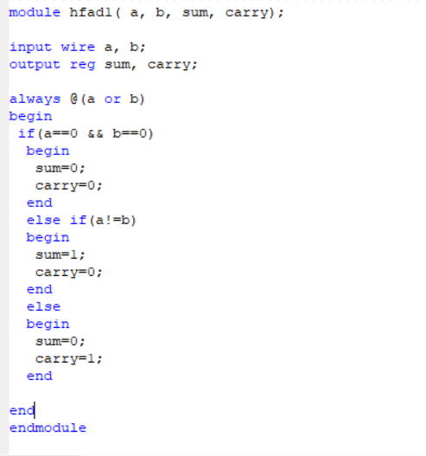

**Half_adder Test Bench:**

module hfad1_tb;

// Inputs

reg a;

reg b;

// Outputs

wire sum;

wire carry;

// Instantiate the Unit Under Test (UUT)

hfad1 uut (

.a(a),

.b(b),

.sum(sum),

.carry(carry)

);

initial begin

// Initialize Inputs

a = 0;

b = 0;

// Wait 100 ns for global reset to finish

#100;

a = 0;

b = 1;

// Wait 100 ns for global reset to finish

#100;

a = 1;

b = 0;

// Wait 100 ns for global reset to finish

#100;

a = 1;

b = 1;

// Wait 100 ns for global reset to finish

#100;

// Add stimulus here

end

endmodule

**Half_Adder RTL:**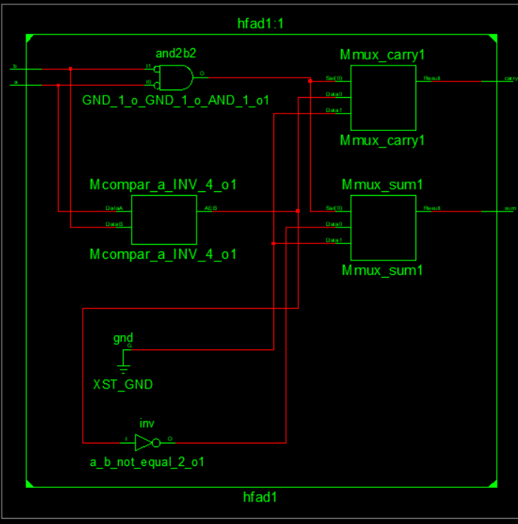

**Graph:** 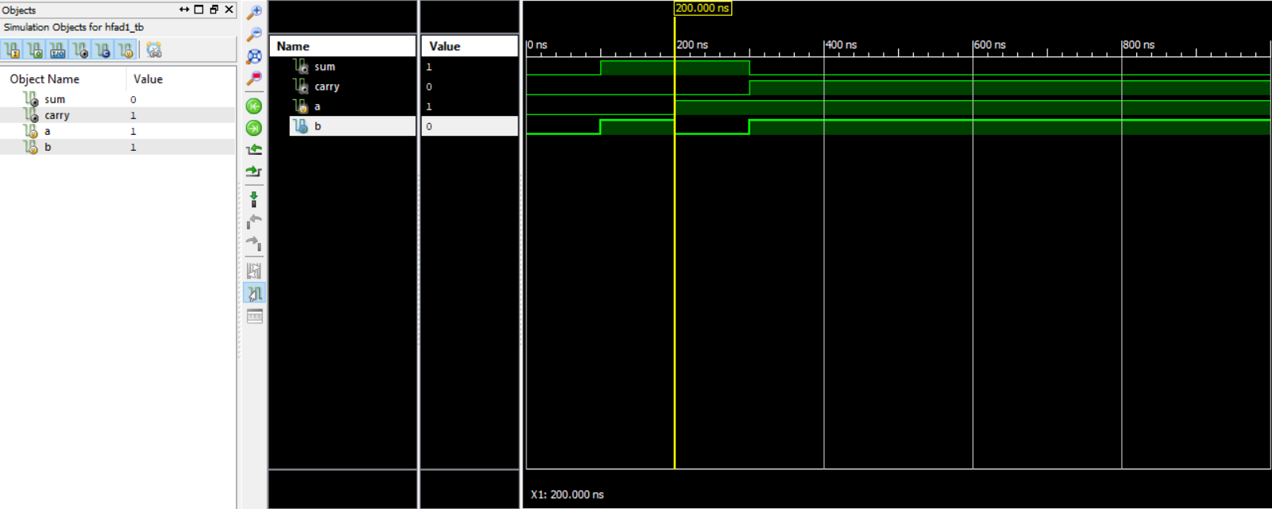

**2-4 decoder verilog_behaviour_model:**

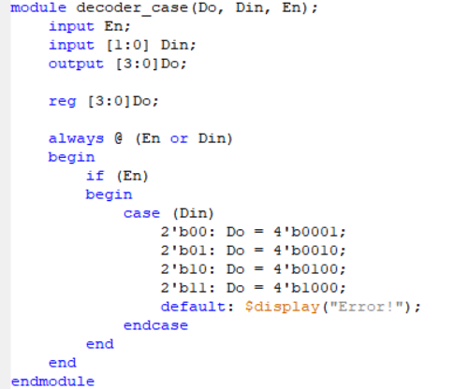

**Test-Bench:**

module TB;

// Inputs

reg [1:0] Din;

reg En;

// Outputs

wire [3:0] Do;

// Instantiate the Unit Under Test (UUT)

decoder_case uut (

.Do(Do),

.Din(Din),

.En(En)

);

initial begin

// Initialize Inputs

Din = 0;

En = 0;

// Wait 100 ns for global reset to finish

#100;

// Add stimulus here

Din = 0;

En = 1;

// Wait 100 ns for global reset to finish

#100;

Din = 1;

En = 1;

// Wait 100 ns for global reset to finish

#100;

end

endmodule

**RTL schematics:**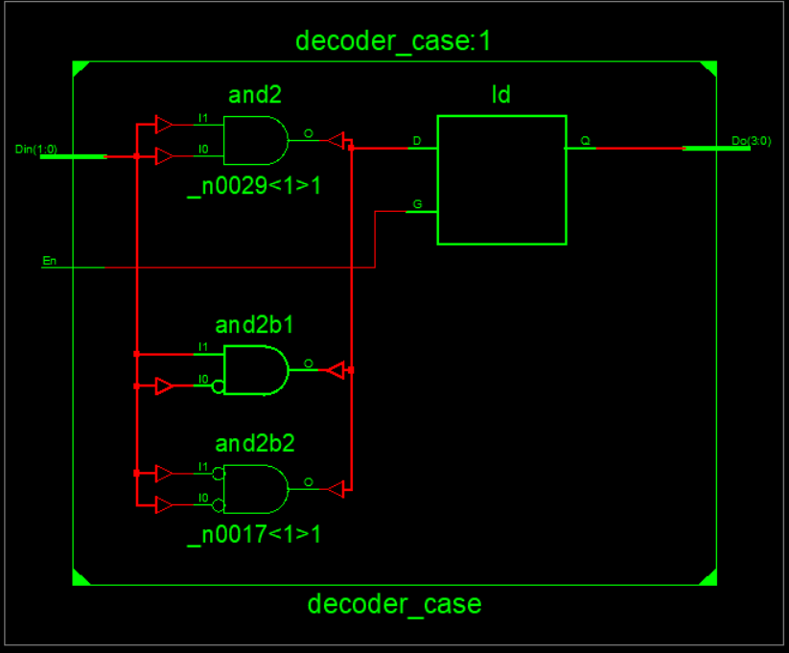

**Graph:** 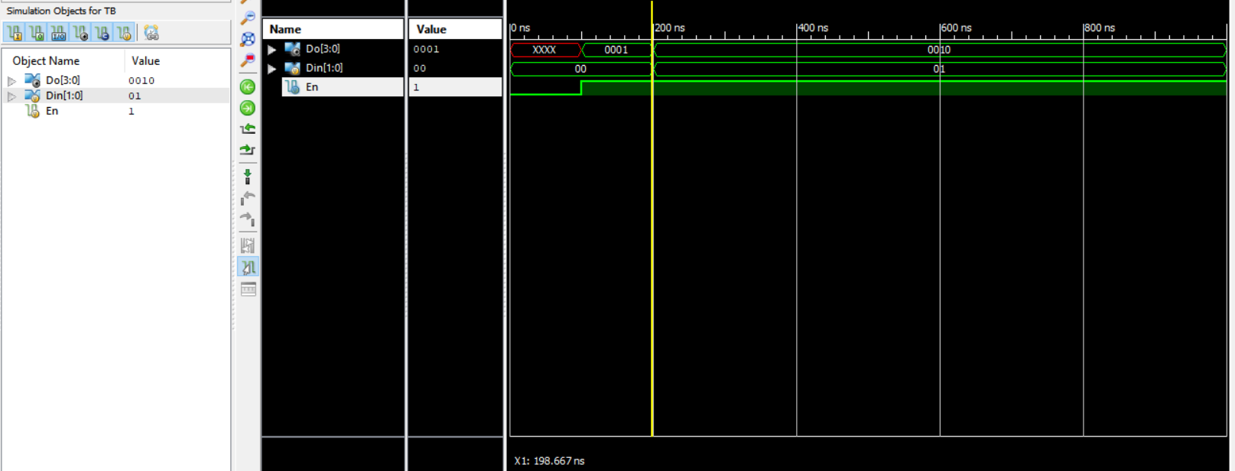

**3-8 decoder verilog:**

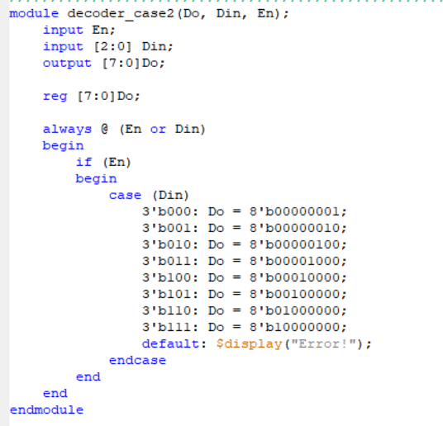

**Test-Bench:**

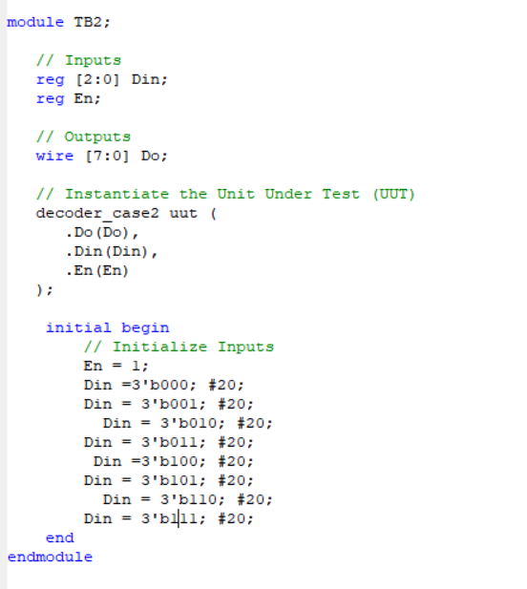

**RTL Schematics:** 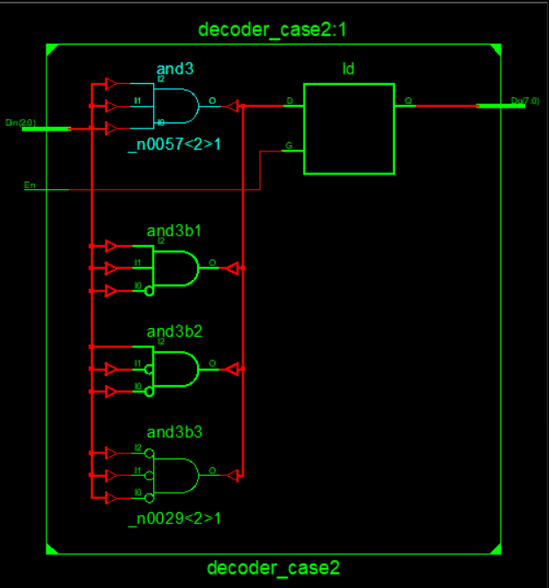

**Graph:** 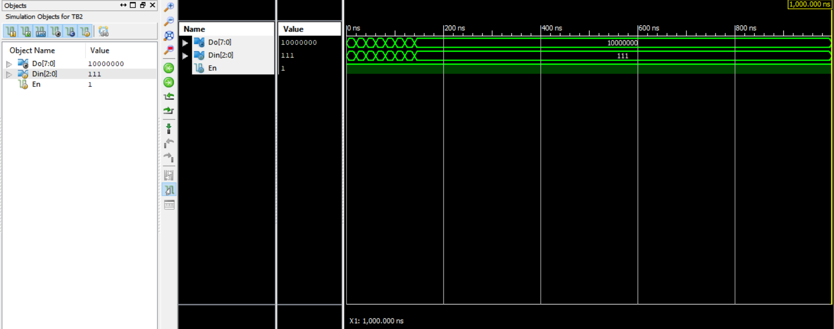

**Decoder 4-16 verilog:**

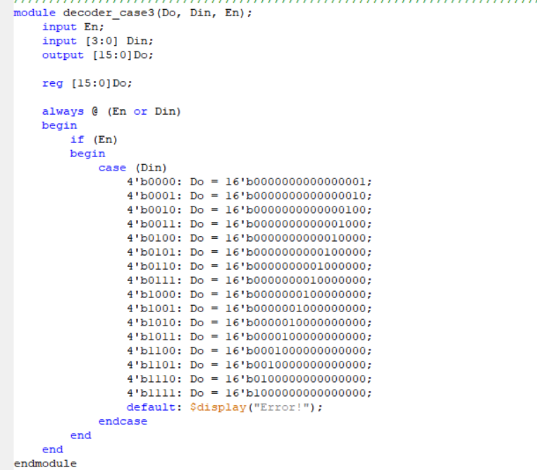

**Test-Bench:**

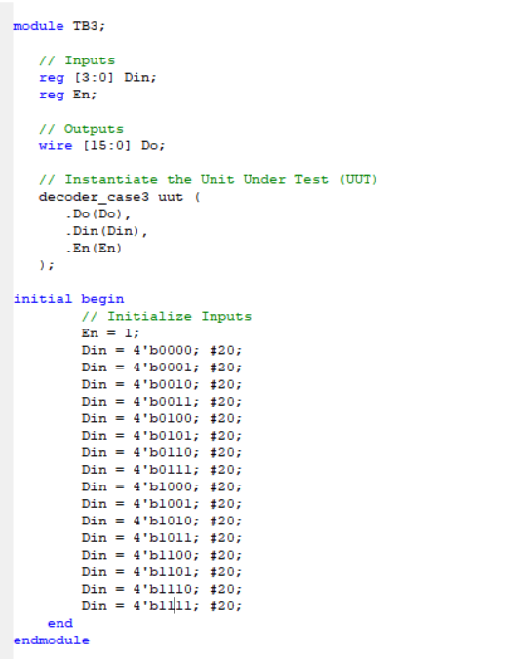

**RTL Schematics:**

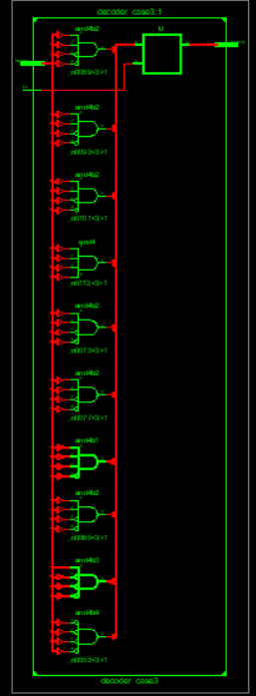

**Graph:** 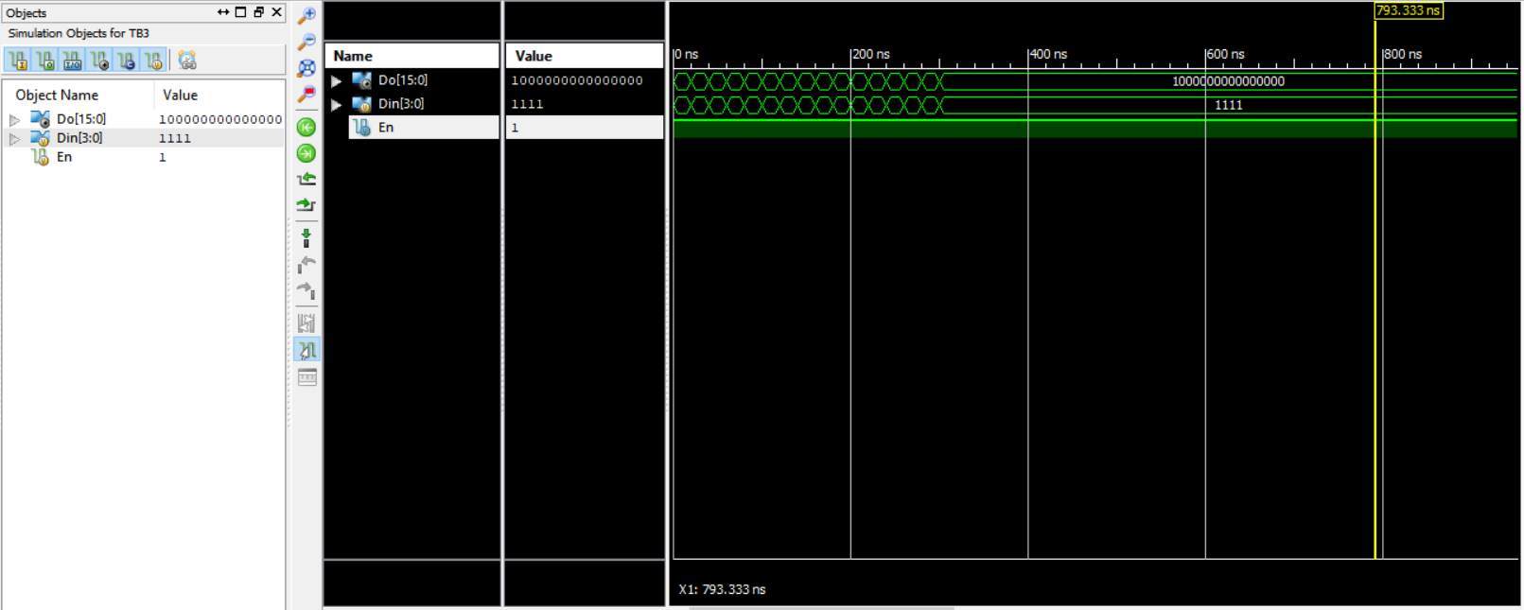

**5-32 decoder verilog:**

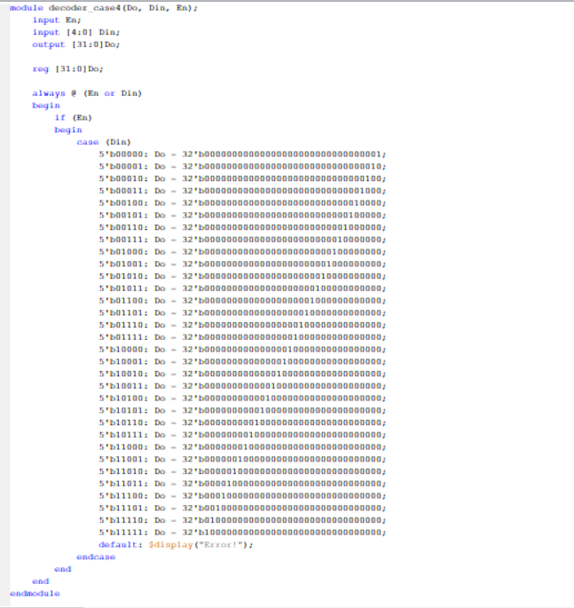

**Test_bench:**

module TB4;

// Inputs

reg [4:0] Din;

reg En;

// Outputs

wire [31:0] Do;

// Instantiate the Unit Under Test (UUT)

decoder_case4 uut (

.Do(Do),

.Din(Din),

.En(En)

);

initial begin

// Initialize Inputs

En = 1;

Din = 5'b00000; #20;

Din = 5'b00001; #20;

Din = 5'b00010; #20;

Din = 5'b00011; #20;

Din = 5'b00100; #20;

Din = 5'b00101; #20;

Din = 5'b00110; #20;

Din = 5'b00111; #20;

Din = 5'b01000; #20;

Din = 5'b01001; #20;

Din = 5'b01010; #20;

Din = 5'b01011; #20;

Din = 5'b01100; #20;

Din = 5'b01101; #20;

Din = 5'b01110; #20;

Din = 5'b01111; #20;

Din = 5'b10000; #20;

Din = 5'b10001; #20;

Din = 5'b10010; #20;

Din = 5'b10011; #20;

Din = 5'b10100; #20;

Din = 5'b10101; #20;

Din = 5'b10110; #20;

Din = 5'b10111; #20;

Din = 5'b11000; #20;

Din = 5'b11001; #20;

Din = 5'b11010; #20;

Din = 5'b11011; #20;

Din = 5'b11100; #20;

Din = 5'b11101; #20;

Din = 5'b11110; #20;

Din = 5'b11111; #20;

end

endmodule

**RTL schematics:**

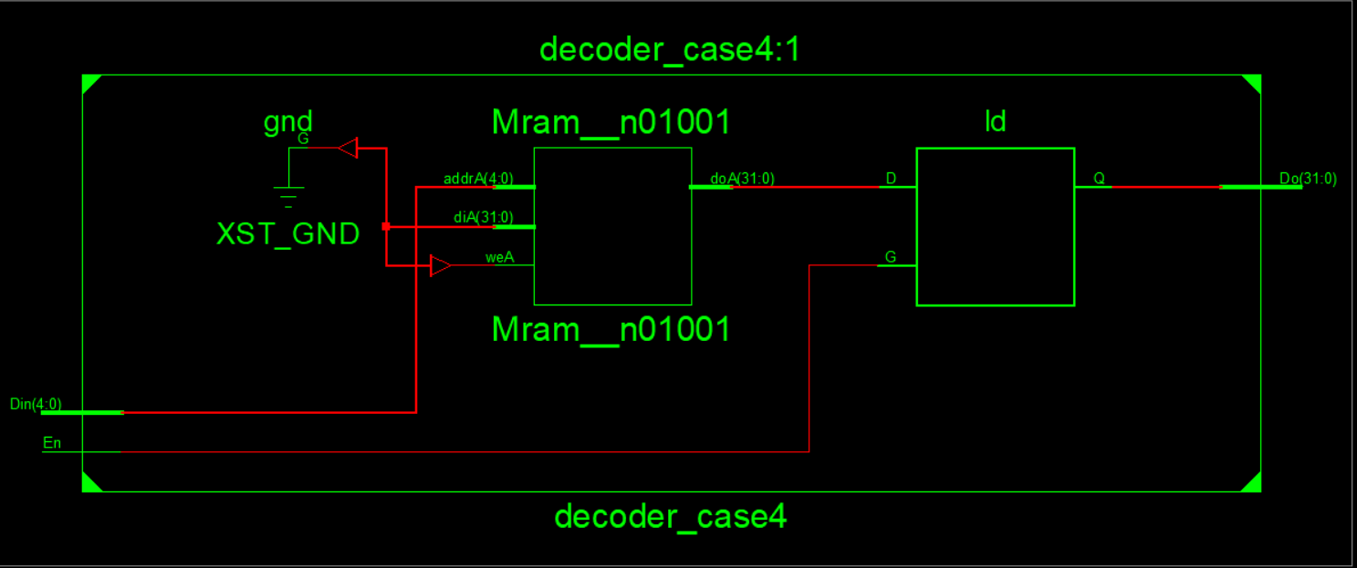

**Tech schematics:**

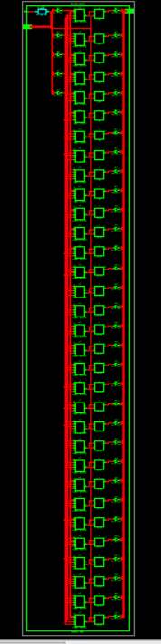

**Graph:** 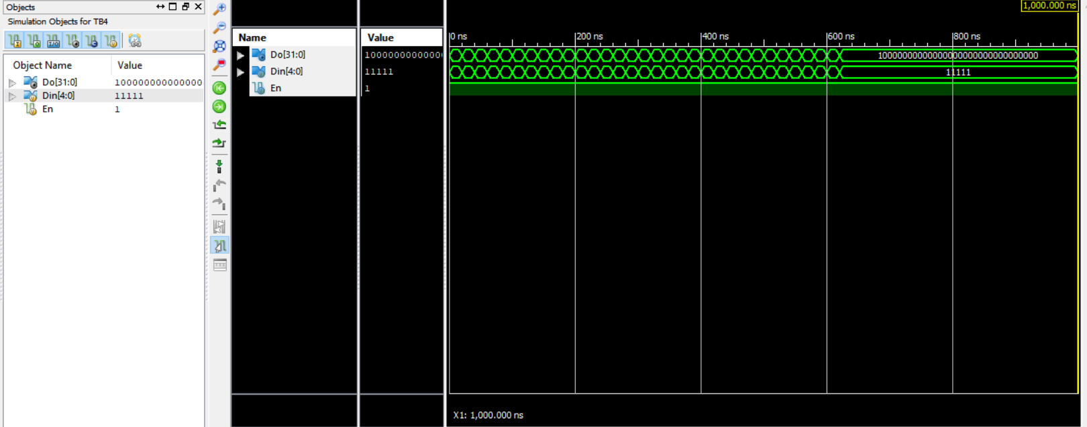

**Encoder 4-2 verilog:**

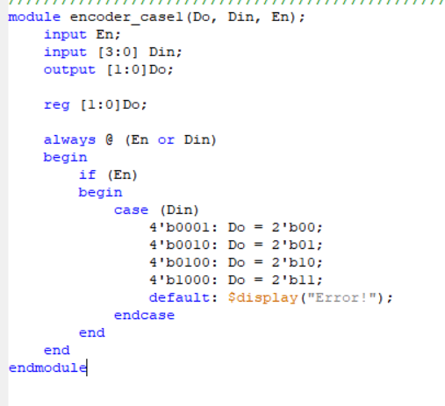

**Test-Bench:**

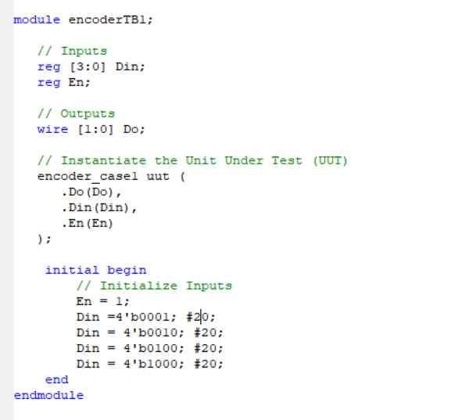

**RTL Schematics:**

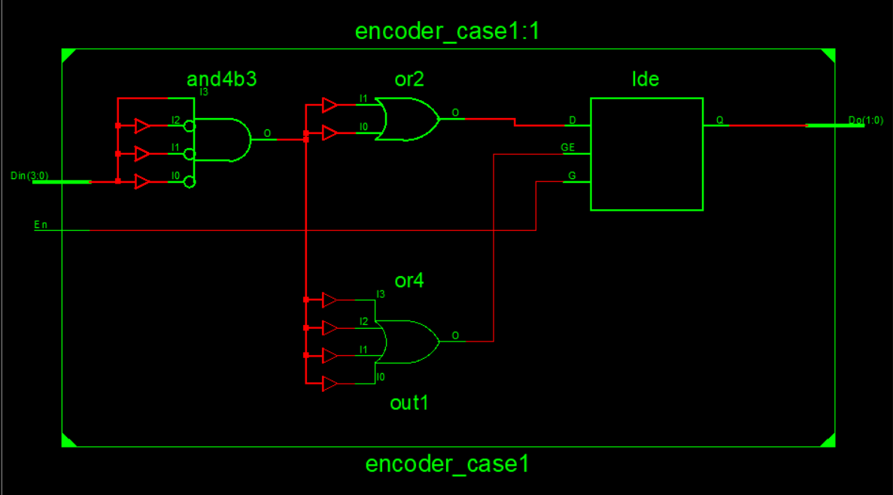

**Graph:** 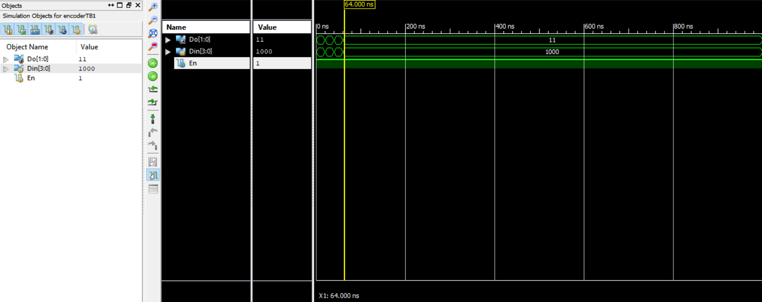

**Encoder 8-3 verilog:**

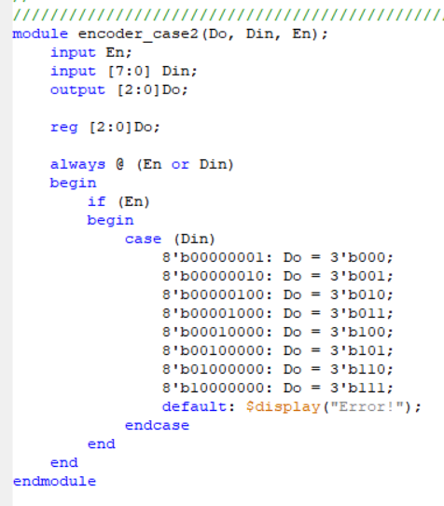

**Test-Bench:**

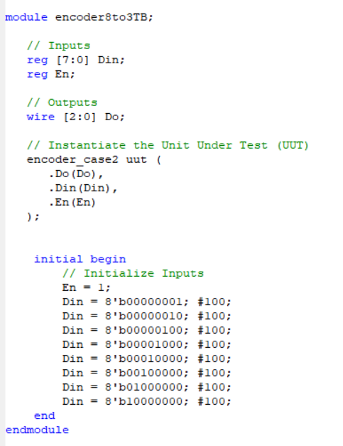

**Tech-RTL Schematics:**

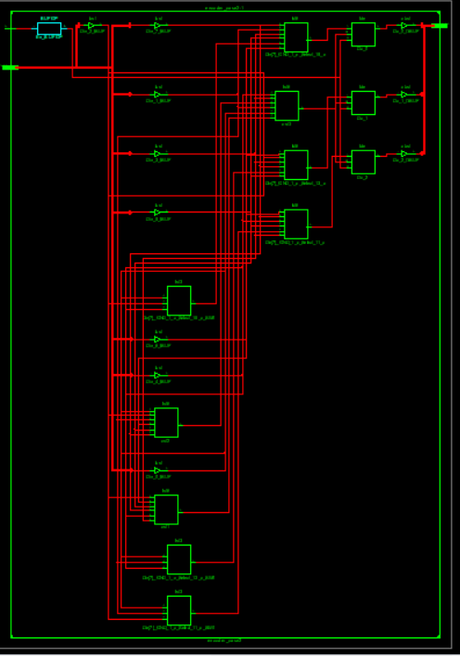

**Graph:** 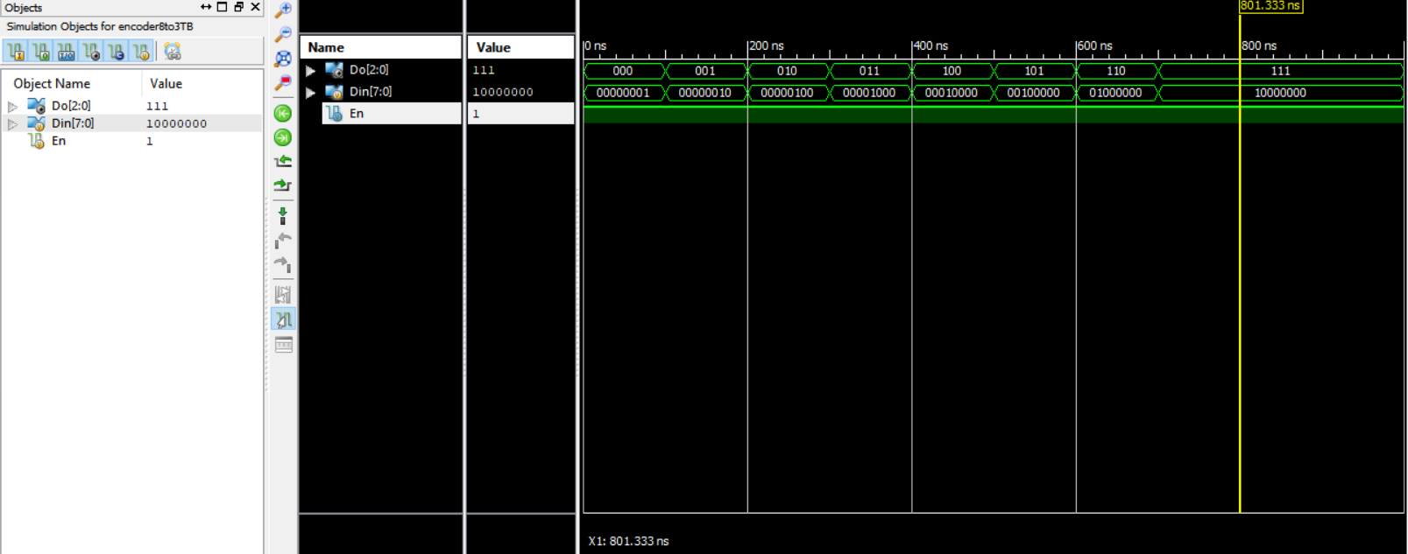

**Encoder16-4 verilog:**

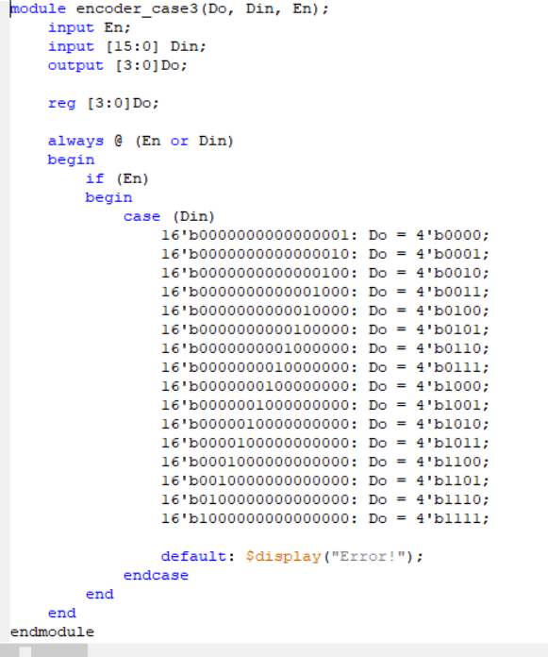

**Test_bench:**

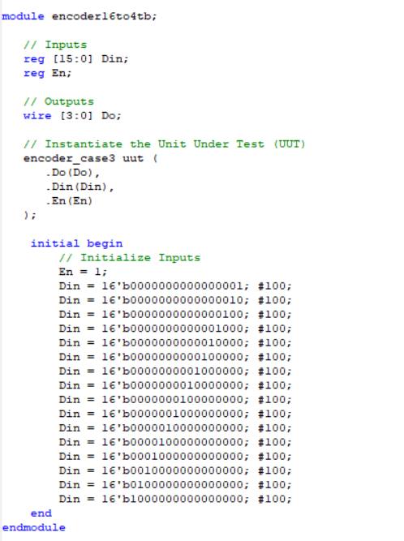

**RTL zoomed part Schematics:**

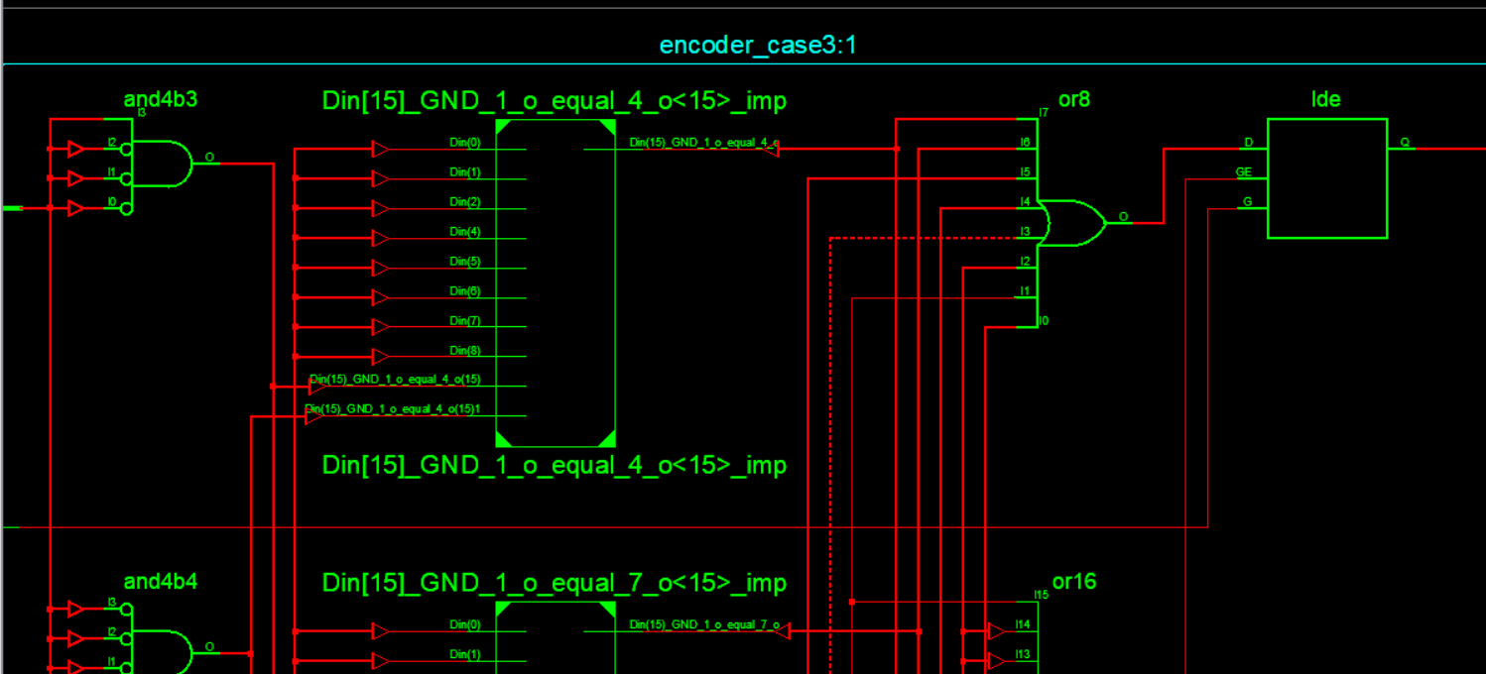

**Graph:**

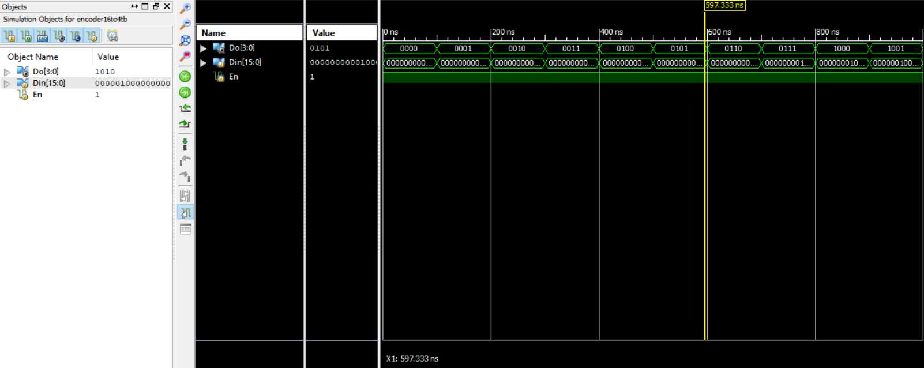

**Multiplexer 2-1 verilog:**

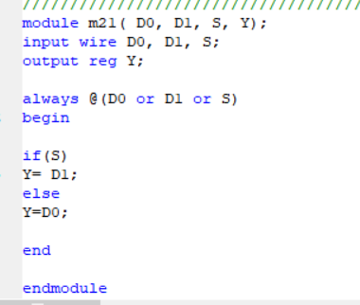

**Test-Bench:**

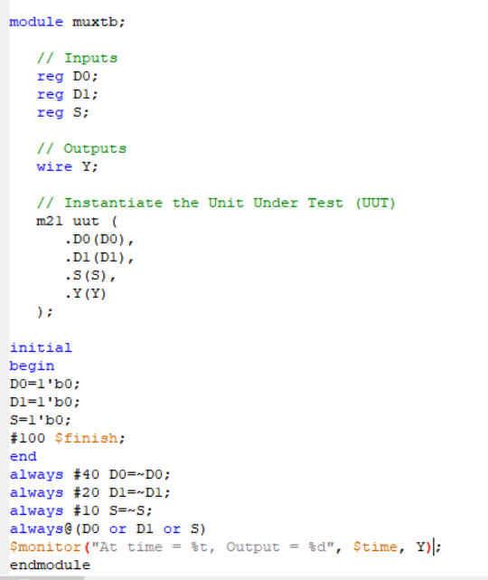

**Technical RTL Schematics:**

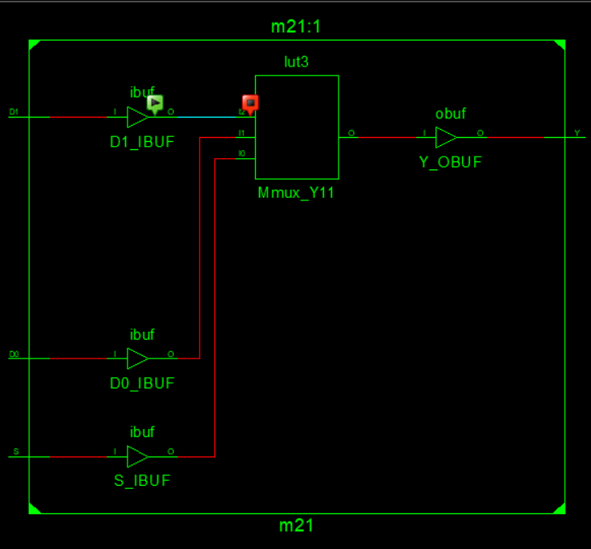

**Graph:**

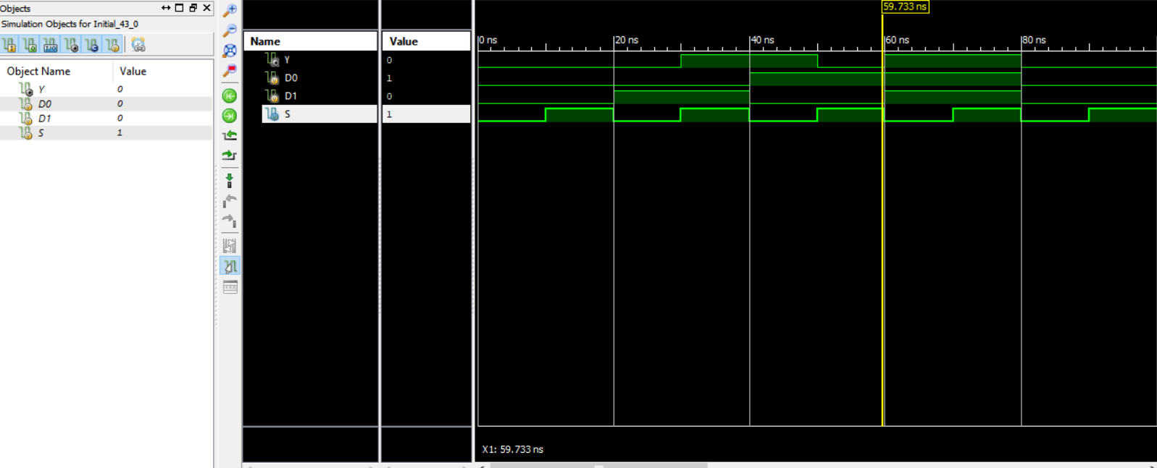

**Multiplexer 4-1 verilog:**

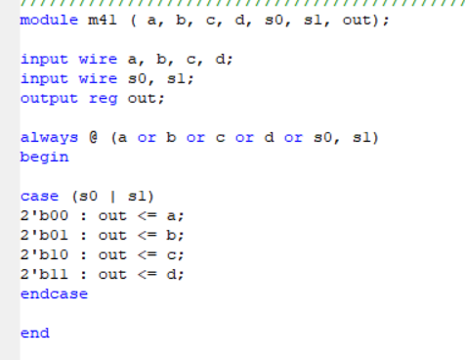

**Test-bench:**

module m41tb;

// Inputs

reg a;

reg b;

reg c;

reg d;

reg s0;

reg s1;

// Outputs

wire out;

// Instantiate the Unit Under Test (UUT)

m41 uut (

.a(a),

.b(b),

.c(c),

.d(d),

.s0(s0),

.s1(s1),

.out(out)

);

initial

begin

a=1'b0; b=1'b0; c=1'b0; d=1'b0;

s0=1'b0; s1=1'b0;

#500 $finish;

end

always #40 a=~a;

always #20 b=~b;

always #10 c=~c;

always #5 d=~d;

always #80 s0=~s0;

always #160 s1=~s1;

always@(a or b or c or d or s0 or s1)

$monitor("At time = %t, Output = %d", $time, out);

Endmodule

**RTL Schematics:**

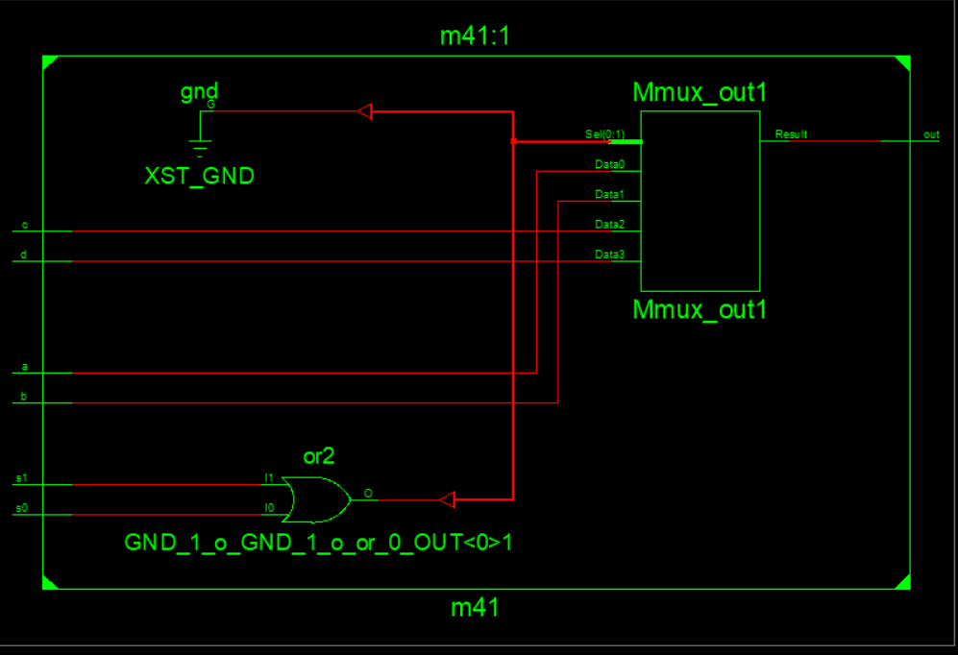

**Graph:**

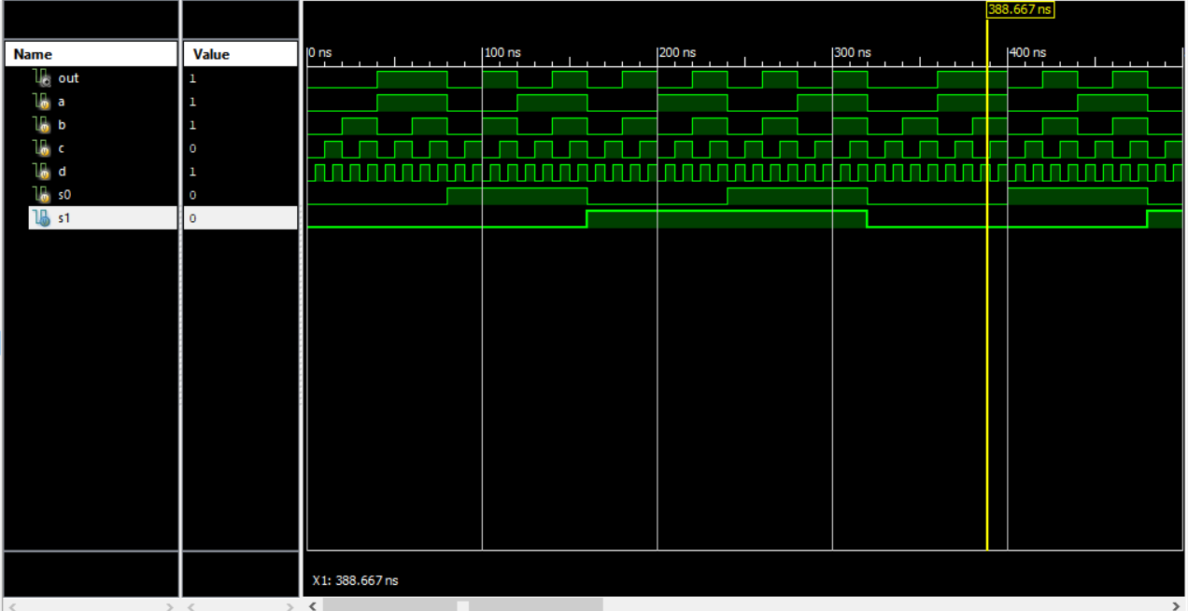

**Mux 8 to 1 verilog:**

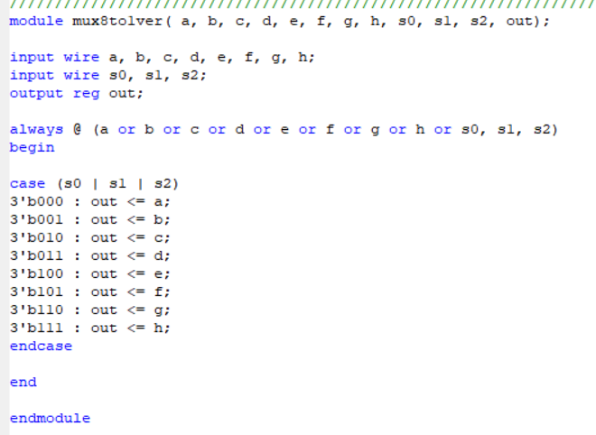

**Test-Bench:**

module mux8to1tb;

// Inputs

reg a;

reg b;

reg c;

reg d;

reg e;

reg f;

reg g;

reg h;

reg s0;

reg s1;

reg s2;

// Outputs

wire out;

// Instantiate the Unit Under Test (UUT)

mux8to1ver uut (

.a(a),

.b(b),

.c(c),

.d(d),

.e(e),

.f(f),

.g(g),

.h(h),

.s0(s0),

.s1(s1),

.s2(s2),

.out(out)

);

initial

begin

a=1'b0; b=1'b0; c=1'b0; d=1'b0; e=1'b0; f=1'b0; g=1'b0; h=1'b0;s0=1'b0; s1=1'b0; s2=1'b0;

#500 $finish;

end

always #1 a=~a;

always #2 b=~b;

always #3 c=~c;

always #4 d=~d;

always #5 e=~e;

always #6 f=~f;

always #7 g=~g;

always #8 h=~h;

always #9 s0=~s0;

always #10 s1=~s1;

always #11 s2=~s2;

always@(a or b or c or d or e or f or g or h or s0 or s1 or s2)

$monitor("At time = %t, Output = %d", $time, out);

endmodule

**RTL Schematics:**

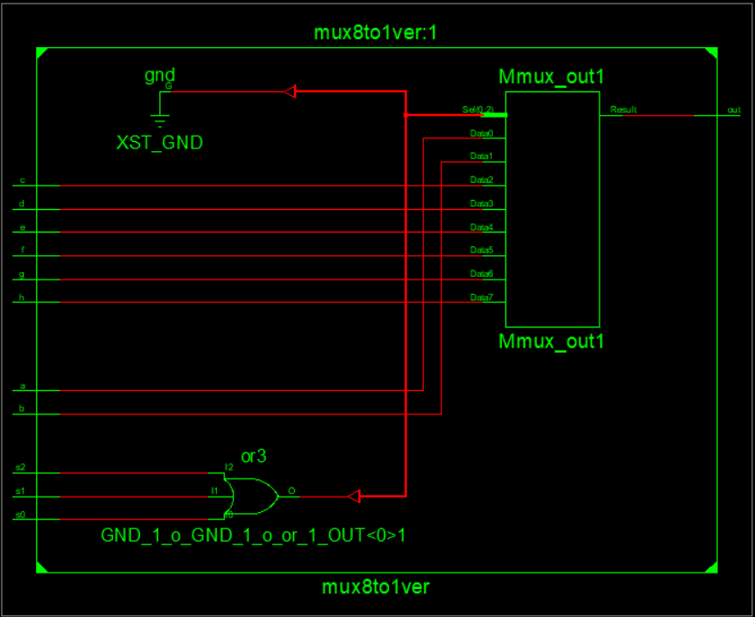

**Graph:**

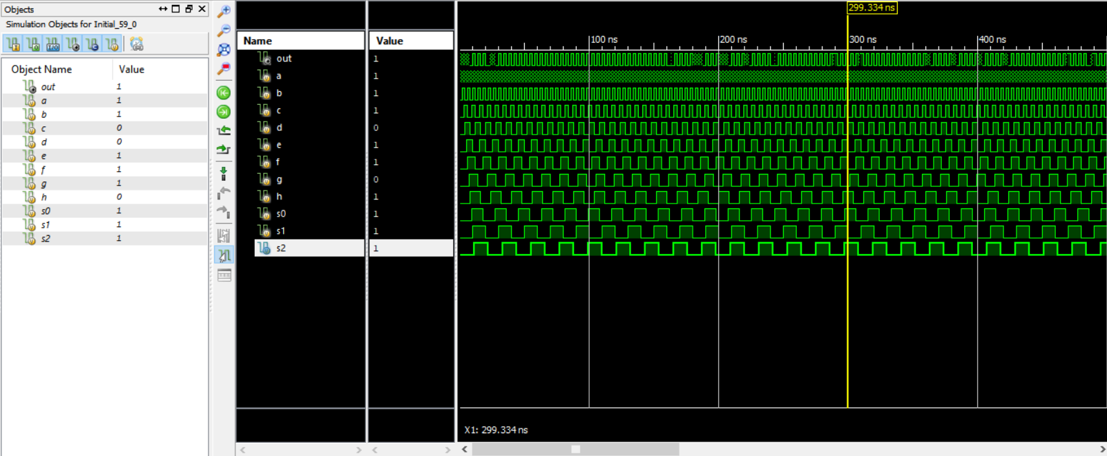

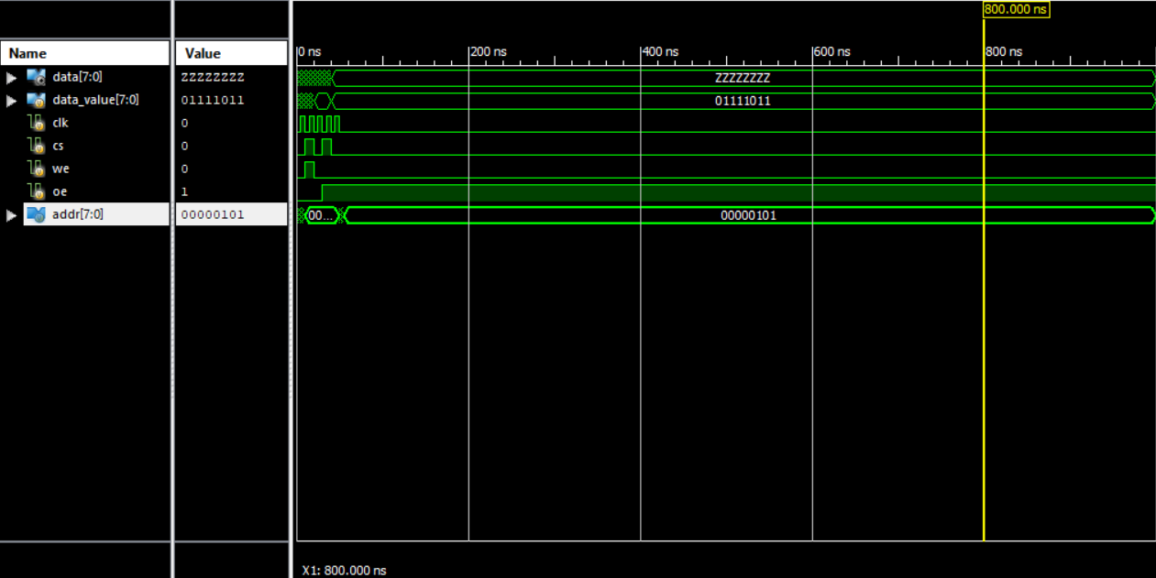

**Single port Ram verilog:**

module single_port_sync_ram (

clk , // Clock Input

address , // Address Input

data , // Data bi-directional

cs , // Chip Select

we , // Write Enable/Read Enable

oe // Output Enable

);

// Setup some parameters

parameter DATA_WIDTH = 8; // word size of the memory

parameter ADDR_WIDTH = 8; // number of memory words, e.g. 2^8-1

parameter RAM_DEPTH = 1 << ADDR_WIDTH;

// Define inputs

input clk, cs, we, oe;

input [ADDR_WIDTH-1:0] address;

// Data is bidirectional

inout [DATA_WIDTH-1:0] data;

// Private registers

reg [DATA_WIDTH-1:0] mem [0:RAM_DEPTH-1]; // Set up the memory array

reg [DATA_WIDTH-1:0] r_data; // copy of data value to return

reg r_oe; // delayed oe, r_oe updates only when rdata updated

// START OF OPERATION: ///////////////////////////////////////////////

// Tri-State Buffer control:

// The data item is defined as an inout, only when oe, output enabled

// is high, should it send a value to data, otherwise it should keep

// the data port linked to high impedence (z) so as not to drive a value.

// i.e. output to data happens when oe = 1 & cs = 1 & we = 0

// Write to memory when: we = 1 & cs = 1

always@ (posedge clk)

begin

if (cs)

begin

if (we) mem[address] <= data;

r_data <= mem[address];

end

r_oe <= oe;

end

assign data = (oe && cs && !we)? r_data : 8'bz;

endmodule //

**Test Bench:**

module tb;

parameter ADDR_WIDTH = 4;

parameter DATA_WIDTH = 16;

parameter DEPTH = 16;

reg clk;

reg cs;

reg we;

reg oe;

reg [ADDR_WIDTH-1:0] address;

wire [DATA_WIDTH-1:0] data;

reg [DATA_WIDTH-1:0] tb_data;

single_port_sync_ram (.DATA_WIDTH(DATA_WIDTH))

u0(

.clk(clk),

.address(address),

.data(data),

.cs(cs),

.we(we),

.oe(oe)

);

always #10 clk = ~clk;

assign data = !oe ? tb_data : 'hz;

integer i;

initial begin

{clk, cs, we, address, tb_data, oe} <= 0;

repeat (2) @ (posedge clk);

for ( i = 0; i < 2**ADDR_WIDTH; i= i+1) begin

repeat (1) @(posedge clk) address <= i; we <= 1; cs <= 1; oe <= 0; tb_data <= $random;

end

for ( i = 0; i < 2**ADDR_WIDTH; i= i+1) begin

repeat (1) @(posedge clk) address <= i; we <= 0; cs <= 1; oe <= 1;

end

#20 $finish;

end

endmodule

**RTL Schematics:**

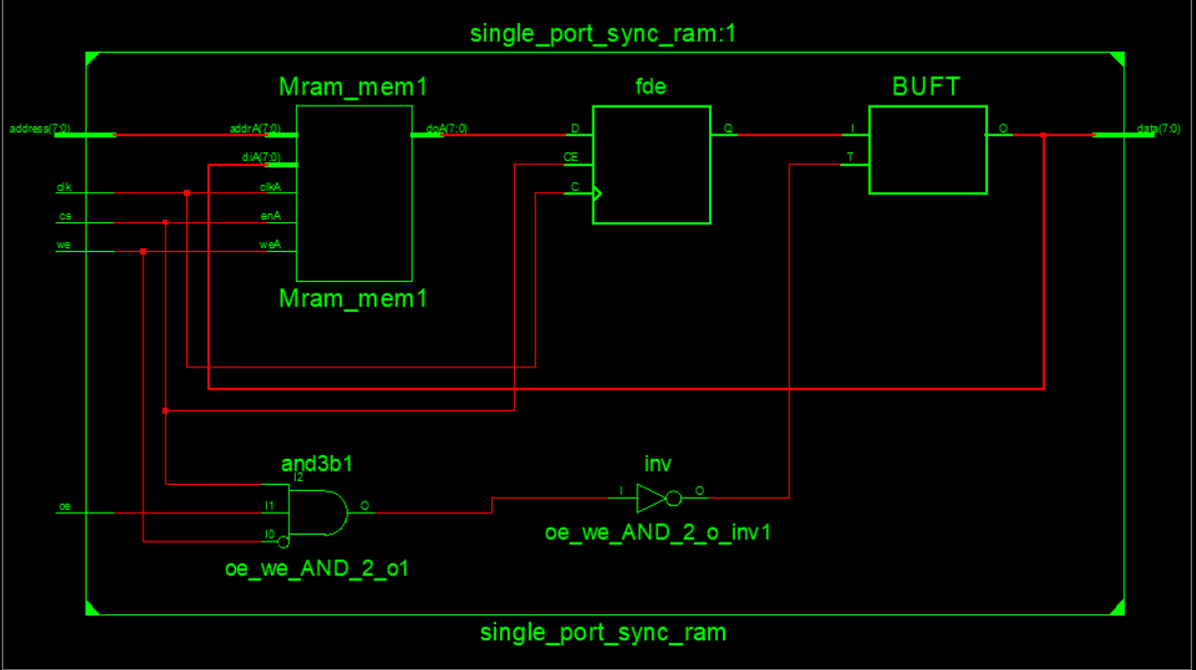

**Technical Schematics:**

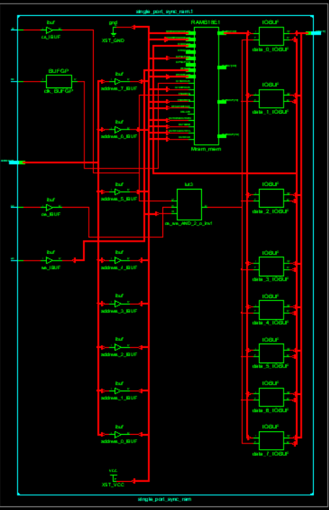

**Graph:**

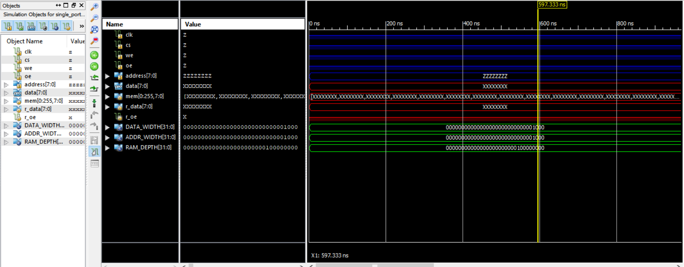

**Mux 16-1 verilog:**

module mux16to1v( d1, d2, d3, d4, d5, d6, d7, d8, d9, d10, d11, d12, d13, d14, d15, d16, s0, s1, s2, s3, out);

input wire d1, d2, d3, d4, d5, d6, d7, d8, d9, d10, d11, d12, d13, d14, d15, d16;

input wire s0, s1, s2, s3;

output reg out;

always @ (d1 or d2 or d3 or d4 or d5 or d6 or d7 or d8 or d9 or d10 or d11 or d12 or d13 or d14 or d15 or d16 or s0, s1, s2, s3)

begin

case (s0 | s1 | s2 | s3)

4'b0000 : out <= d1;

4'b0001 : out <= d2;

4'b0010 : out <= d3;

4'b0011 : out <= d4;

4'b0100 : out <= d5;

4'b0101 : out <= d6;

4'b0110 : out <= d7;

4'b0111 : out <= d8;

4'b1000 : out <= d9;

4'b1001 : out <= d10;

4'b1010 : out <= d11;

4'b1011 : out <= d12;

4'b1100 : out <= d13;

4'b1101 : out <= d14;

4'b1110 : out <= d15;

4'b1111 : out <= d16;

endcase

end

endmodule

**Test Bench:**

module mux16to1tb;

// Inputs

reg d1;

reg d2;

reg d3;

reg d4;

reg d5;

reg d6;

reg d7;

reg d8;

reg d9;

reg d10;

reg d11;

reg d12;

reg d13;

reg d14;

reg d15;

reg d16;

reg s0;

reg s1;

reg s2;

reg s3;

// Outputs

wire out;

// Instantiate the Unit Under Test (UUT)

mux16to1v uut (

.d1(d1),

.d2(d2),

.d3(d3),

.d4(d4),

.d5(d5),

.d6(d6),

.d7(d7),

.d8(d8),

.d9(d9),

.d10(d10),

.d11(d11),

.d12(d12),

.d13(d13),

.d14(d14),

.d15(d15),

.d16(d16),

.s0(s0),

.s1(s1),

.s2(s2),

.s3(s3),

.out(out)

);

initial

begin

d1=1'b0; d2=1'b0; d3=1'b0; d4=1'b0; d5=1'b0; d6=1'b0; d7=1'b0; d8=1'b0; d9=1'b0; d10=1'b0; d11=1'b0; d12=1'b0; d13=1'b0; d14=1'b0; d15=1'b0; d16=1'b0; s0=1'b0; s1=1'b0; s2=1'b0; s3=1'b0;

#500 $finish;

end

always #1 d1=~d1;

always #2 d2=~d2;

always #3 d3=~d3;

always #4 d4=~d4;

always #5 d5=~d5;

always #6 d6=~d6;

always #7 d7=~d7;

always #8 d8=~d8;

always #1 d9=~d9;

always #2 d10=~d10;

always #3 d11=~d11;

always #4 d12=~d12;

always #5 d13=~d13;

always #6 d14=~d14;

always #7 d15=~d15;

always #8 d16=~d16;

always #9 s0=~s0;

always #10 s1=~s1;

always #11 s2=~s2;

always #11 s3=~s3;

always@(d1 or d2 or d3 or d4 or d5 or d6 or d7 or d8 or d9 or d10 or d11 or d12 or d13 or d14 or d15 or d16 or s0 or s1 or s2 or s3)

$monitor("At time = %t, Output = %d", $time, out);

Endmodule

**RTL schematics:**

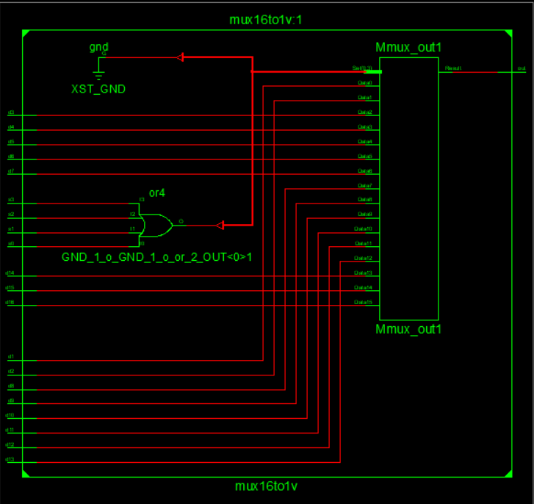

**Graph:**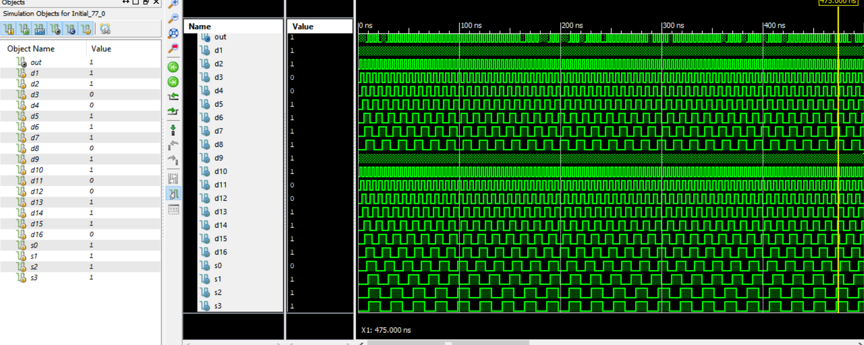

**Demux 1-2:**

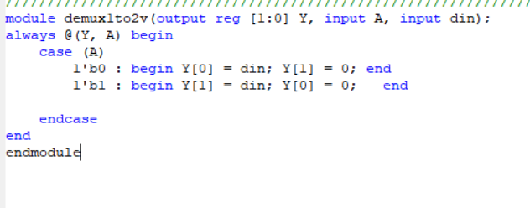

**Test bench:**

module demux1to2tb;

// Inputs

reg A;

reg din;

// Outputs

wire [1:0] Y;

// Instantiate the Unit Under Test (UUT)

demux1to2v uut (

.Y(Y),

.A(A),

.din(din)

);

initial begin

// Initialize Inputs

A = 0;

din = 0;

// Wait 100 ns for global reset to finish

#100;

A = 0;

din = 1;

// Wait 100 ns for global reset to finish

#100;

A = 1;

din = 0;

// Wait 100 ns for global reset to finish

#100;

A = 1;

din = 1;

// Wait 100 ns for global reset to finish

#100;

// Add stimulus here

end

endmodule

**RTL Schematics:**

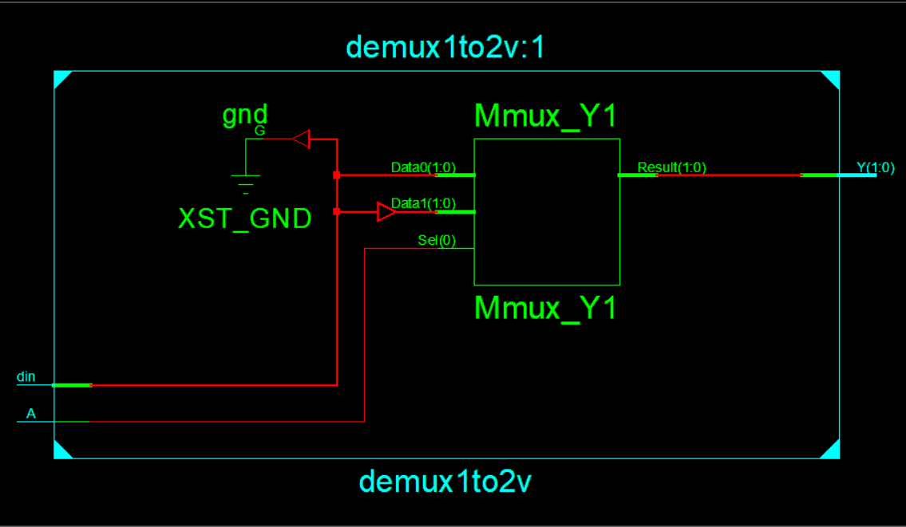

**Graph:**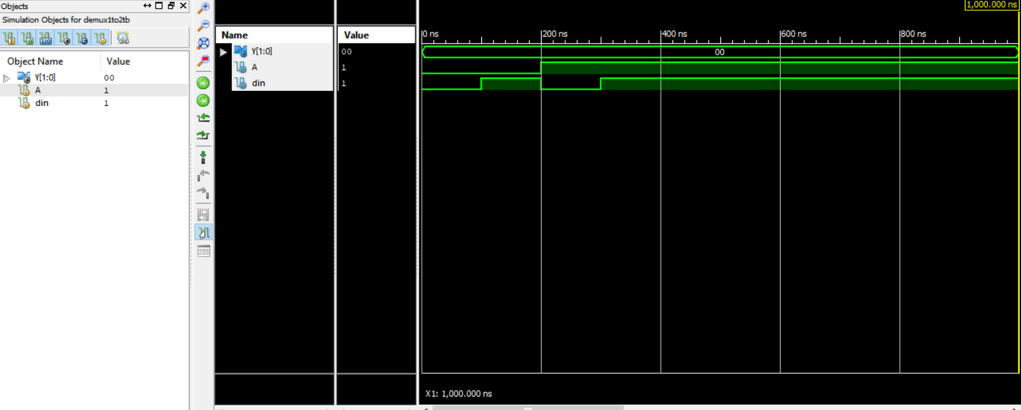

**Demux 1 to 4:**

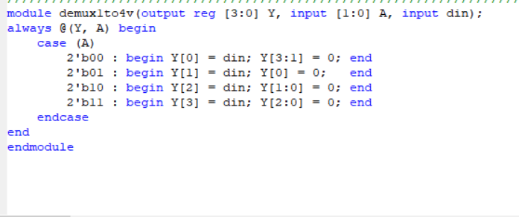

**Test Bench:**

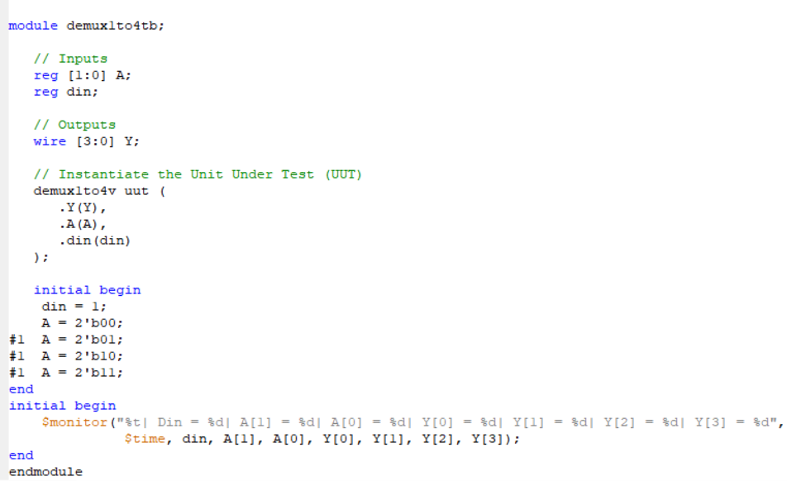

**RTL Schematics:**

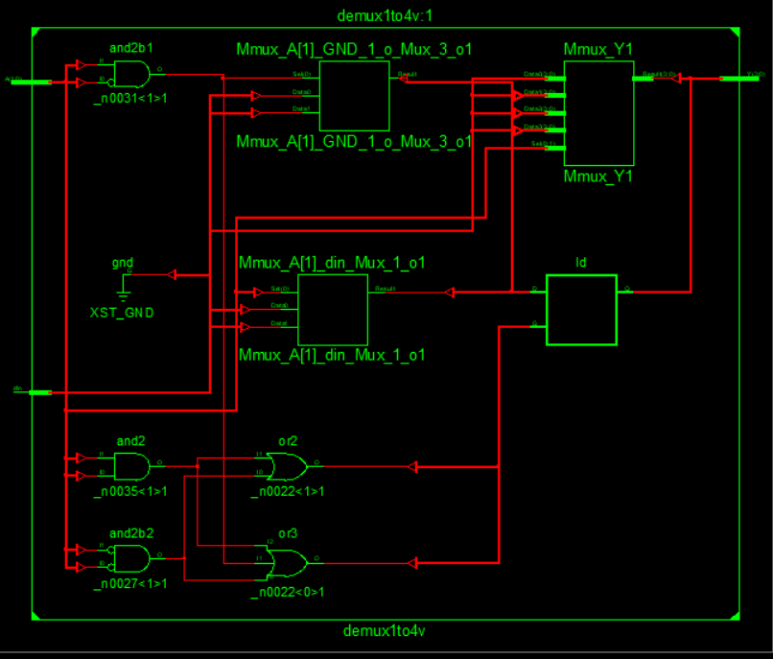

**Graph:** 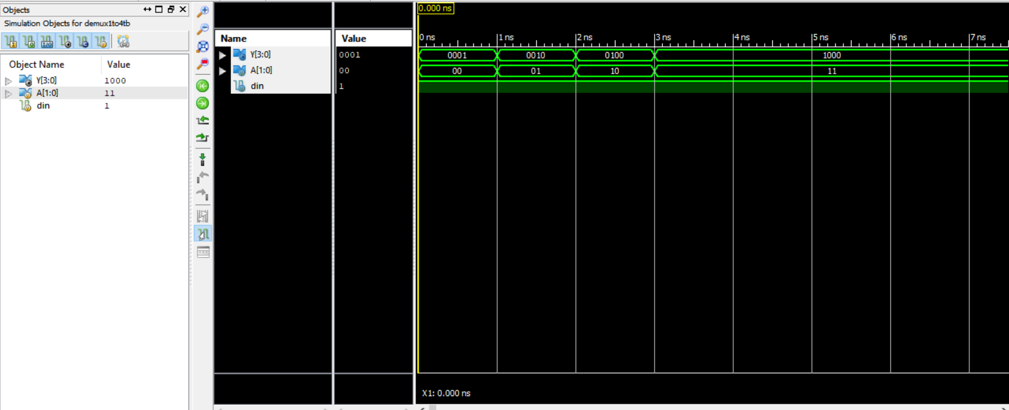

**Demux1to8 verilog:**

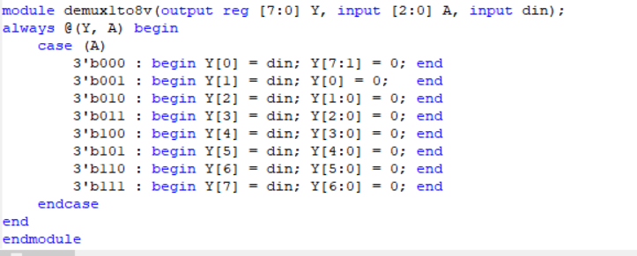

**Test Bench:**

module demux1to8tb;

// Inputs

reg [2:0] A;

reg din;

// Outputs

wire [7:0] Y;

// Instantiate the Unit Under Test (UUT)

demux1to8v uut (

.Y(Y),

.A(A),

.din(din)

);

initial begin

din = 1;

A = 3'b000;

#1 A = 3'b001;

#1 A = 3'b010;

#1 A = 3'b011;

#1 A = 3'b100;

#1 A = 3'b101;

#1 A = 3'b110;

#1 A = 3'b111;

end

initial begin

$monitor("%t| Din = %d| A[2] = %d| A[1] = %d| A[0] = %d| Y[0] = %d| Y[1] = %d| Y[2] = %d| Y[3] = %d| Y[4] = %d| Y[5] = %d| Y[6] = %d| Y[7] = %d",

$time, din, A[2], A[1], A[0], Y[0], Y[1], Y[2], Y[3], Y[4], Y[5], Y[6], Y[7]);

end

endmodule

**RTL Schematics:**

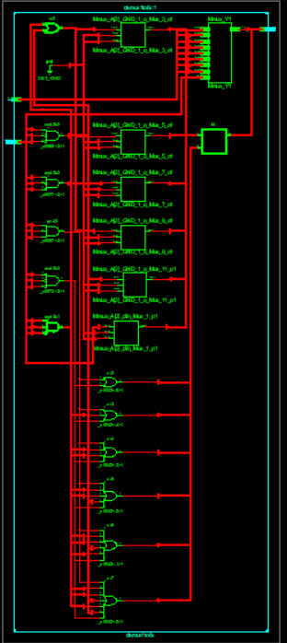

**Graph:** 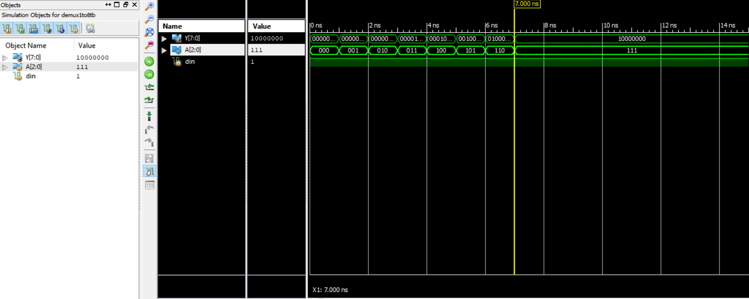

**Demux 1to16 verilog:**

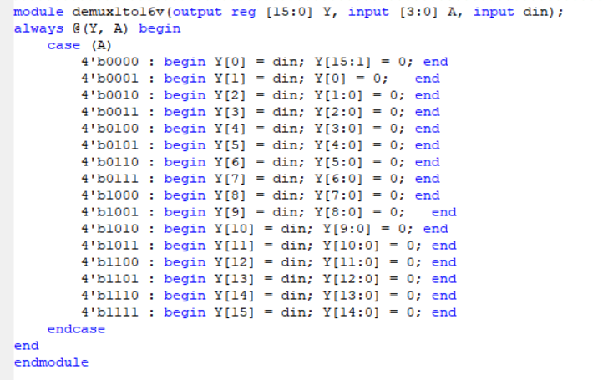

**Test bench:**

module demux1to16tb;

// Inputs

reg [3:0] A;

reg din;

// Outputs

wire [15:0] Y;

// Instantiate the Unit Under Test (UUT)

demux1to16v uut (

.Y(Y),

.A(A),

.din(din)

);

initial begin

din = 1;

A = 4'b0000;

#1 A = 4'b0001;

#1 A = 4'b0010;

#1 A = 4'b0011;

#1 A = 4'b0100;

#1 A = 4'b0101;

#1 A = 4'b0110;

#1 A = 4'b0111;

#1 A = 4'b1000;

#1 A = 4'b1001;

#1 A = 4'b1010;

#1 A = 4'b1011;

#1 A = 4'b1100;

#1 A = 4'b1101;

#1 A = 4'b1110;

#1 A = 4'b1111;

end

initial begin

$monitor("%t| Din = %d| A[3] = %d| A[2] = %d| A[1] = %d| A[0] = %d| Y[0] = %d| Y[1] = %d| Y[2] = %d| Y[3] = %d| Y[4] = %d| Y[5] = %d| Y[6] = %d| Y[7] = %d| Y[8] = %d| Y[9] = %d| Y[10] = %d| Y[11] = %d| Y[12] = %d| Y[13] = %d| Y[14] = %d| Y[15] = %d",

$time, din, A[3],A[2], A[1], A[0], Y[0], Y[1], Y[2], Y[3], Y[4], Y[5], Y[6], Y[7], Y[8], Y[9], Y[10], Y[11], Y[12], Y[13], Y[14], Y[15]);

end

endmodule

**RTL schematics:**

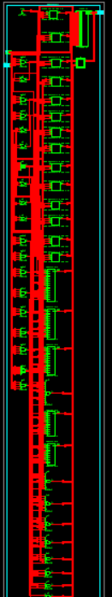

**Graph:** 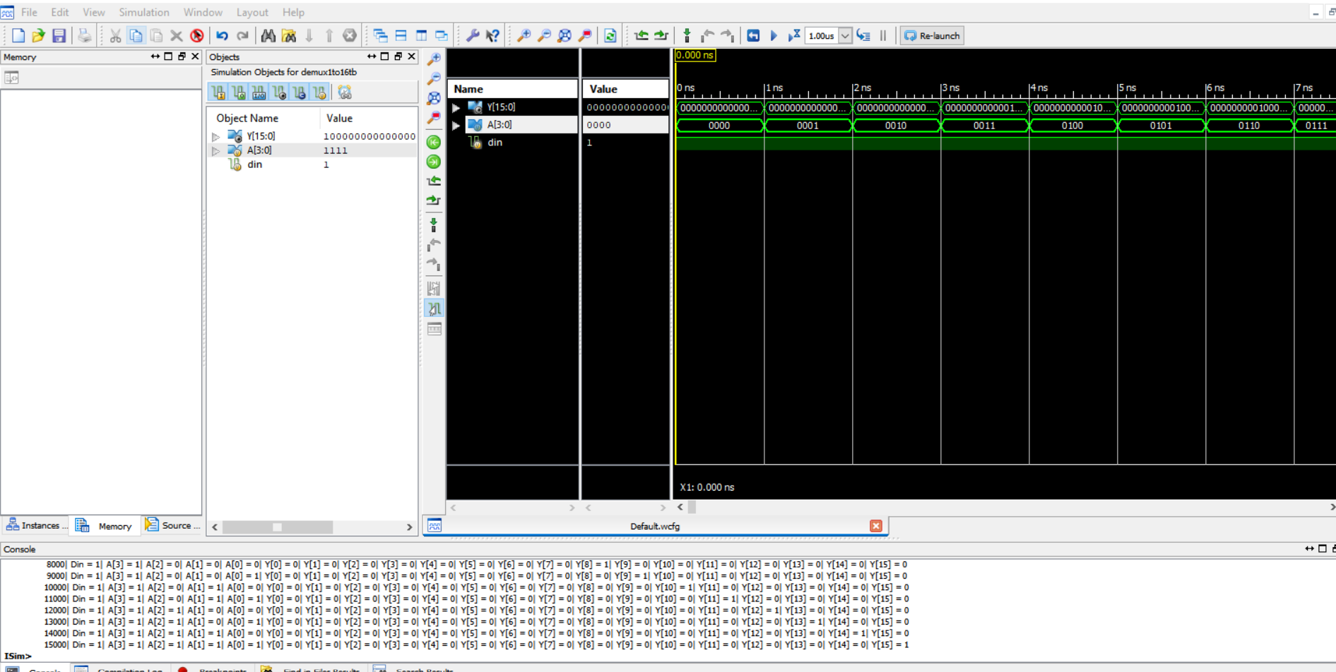

**Working on Image file on verilog:**

**RAM verilog code:**

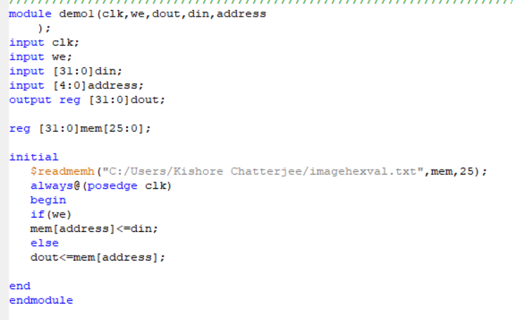

**Test Bench:**

module demo1tb;

// Inputs

reg clk;

reg we;

reg [31:0] din;

reg [4:0] address;

// Outputs

wire [31:0] dout;

// Instantiate the Unit Under Test (UUT)

demo1 uut (

.clk(clk),

.we(we),

.dout(dout),

.din(din),

.address(address)

);

initial begin

// Initialize Inputs

clk = 0;

we = 1;

din = 0;

address = 0;

// Wait 100 ns for global reset to finish

#100;

we = 0;

#100 address = 5'd1;

#110 address = 5'd1;

#120 address = 5'd2;

#130 address = 5'd3;

#140 address = 5'd4;

#150 address = 5'd25;

// Add stimulus here

end

always #5 clk = ~clk;

endmodule

**RTL schematics:**

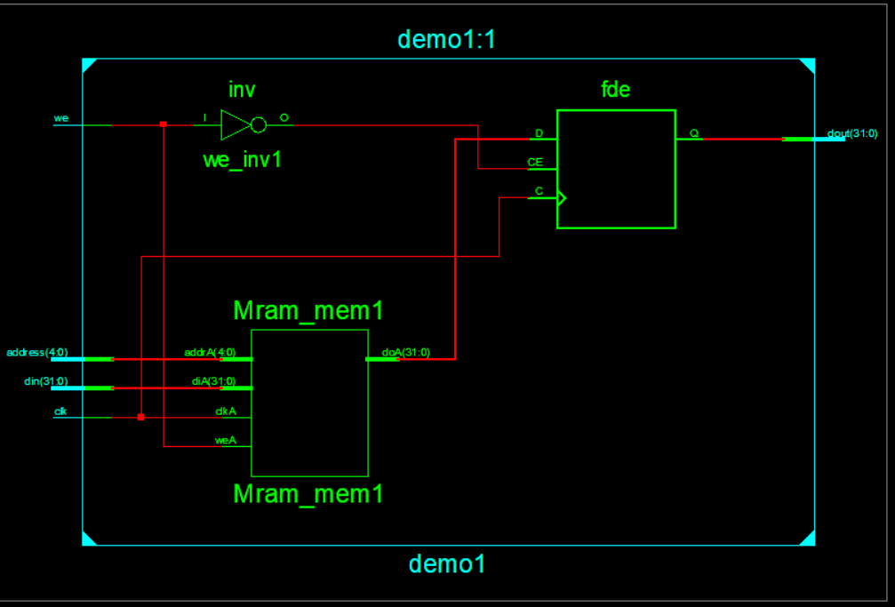

**Technical Schematics:**

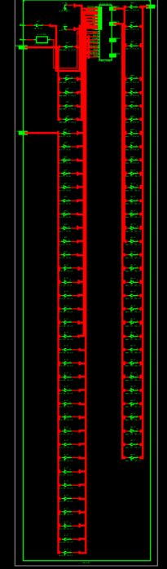

**Graph:** 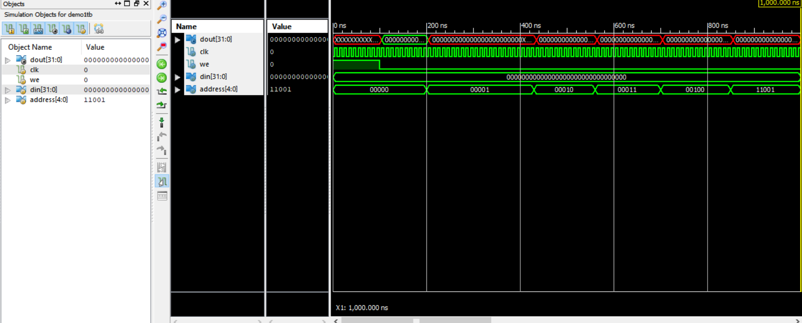

**Python code for the conversion of Image to hexadecimal value:**

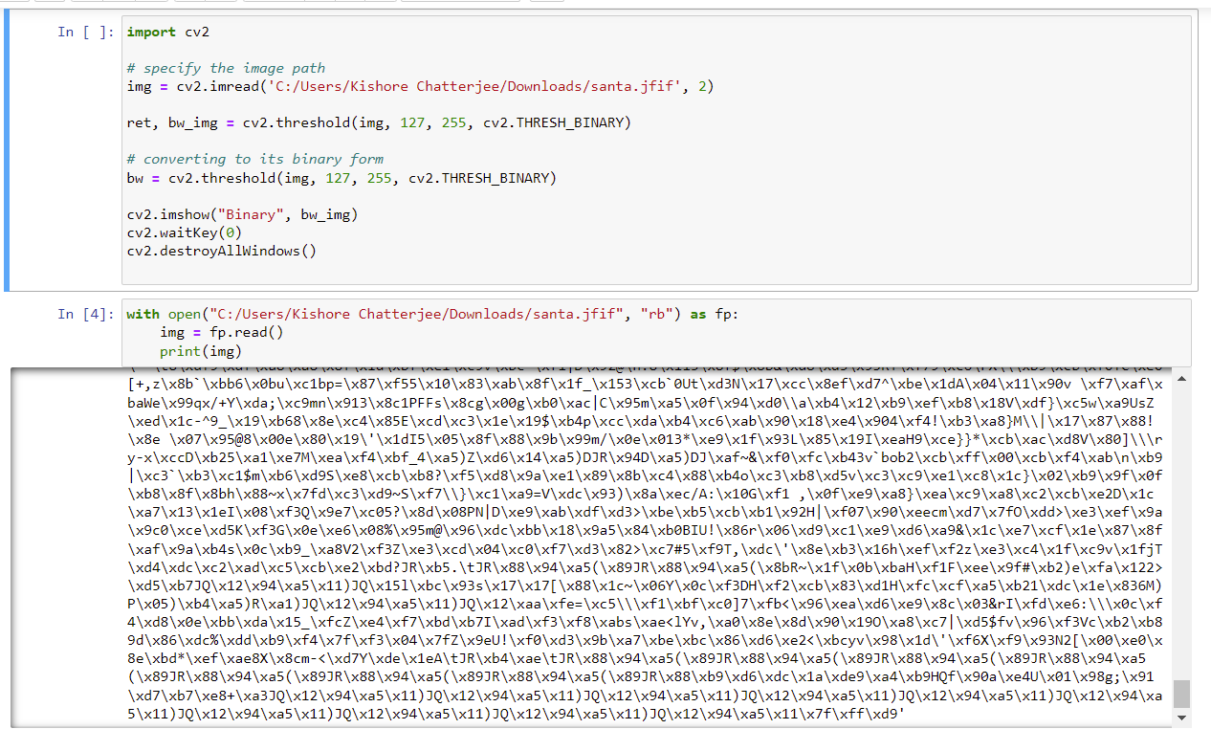

**Getting Hexadecimal Value of Image using Python:**

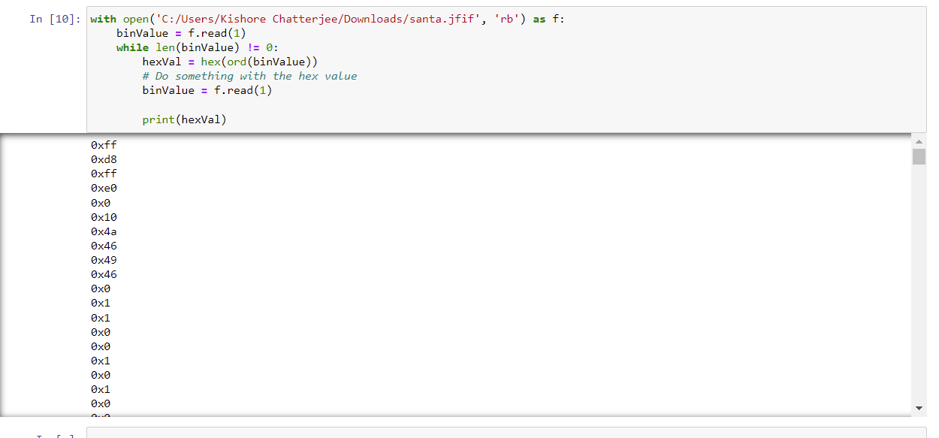

**Image and its Binary Format:**

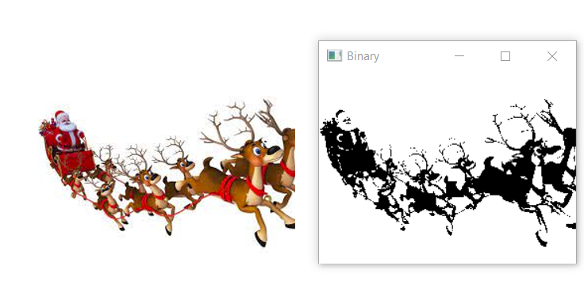

**Dual Port Ram Verilog:**

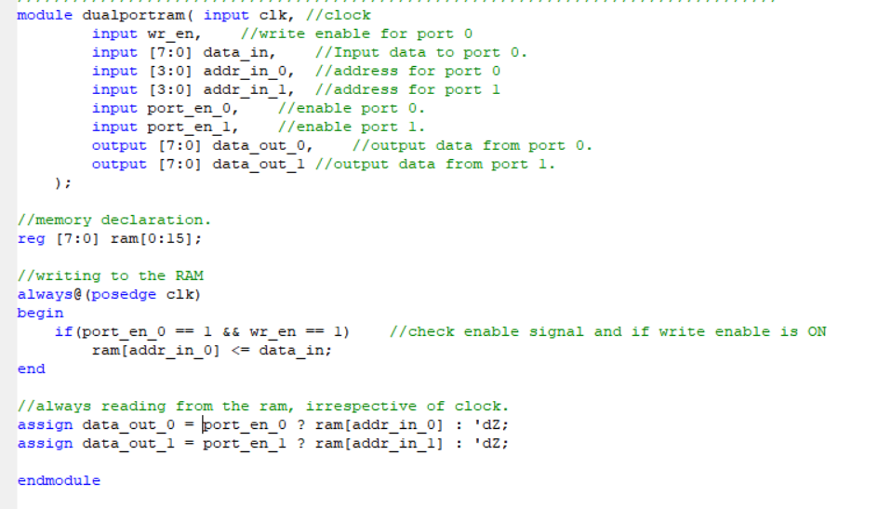

**Test Bench:**

module tb;

integer i;

// Inputs

reg clk;

reg wr_en;

reg [7:0] data_in;

reg [3:0] addr_in_0;

reg [3:0] addr_in_1;

reg port_en_0;

reg port_en_1;

// Outputs

wire [7:0] data_out_0;

wire [7:0] data_out_1;

// Instantiate the Unit Under Test (UUT)

dualportram uut (

.clk(clk),

.wr_en(wr_en),

.data_in(data_in),

.addr_in_0(addr_in_0),

.addr_in_1(addr_in_1),

.port_en_0(port_en_0),

.port_en_1(port_en_1),

.data_out_0(data_out_0),

.data_out_1(data_out_1)

);

always

#5 clk = ~clk;

initial begin

// Initialize Inputs

clk = 1;

addr_in_1 = 0;

port_en_0 = 0;

port_en_1 = 0;

wr_en = 0;

data_in = 0;

addr_in_0 = 0;

#20;

//Write all the locations of RAM

port_en_0 = 1;

wr_en = 1;

for(i=1; i <= 16; i = i + 1) begin

data_in = i;

addr_in_0 = i-1;

#10;

end

wr_en = 0;

port_en_0 = 0;

//Read from port 1, all the locations of RAM.

port_en_1 = 1;

for(i=1; i <= 16; i = i + 1) begin

addr_in_1 = i-1;

#10;

end

port_en_1 = 0;

end

endmodule

**RTL schematics:**

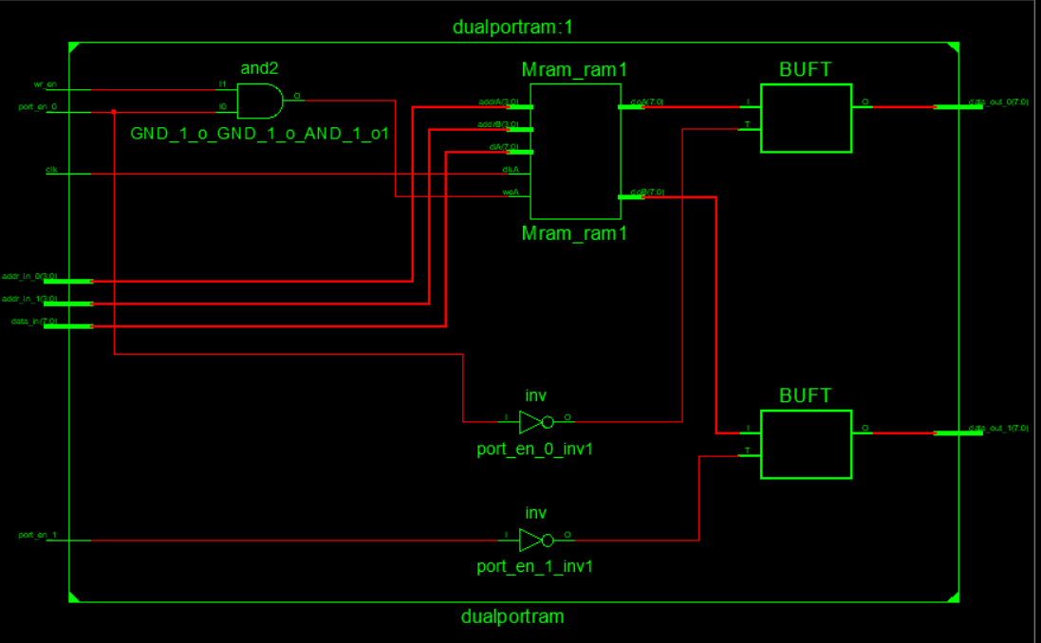

**Technical Schematics:**

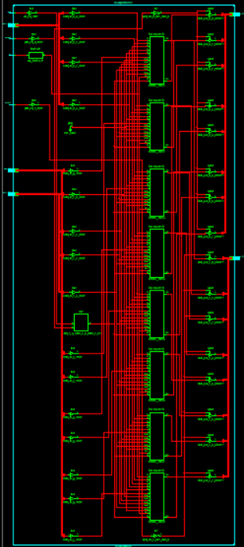

**Graph:**

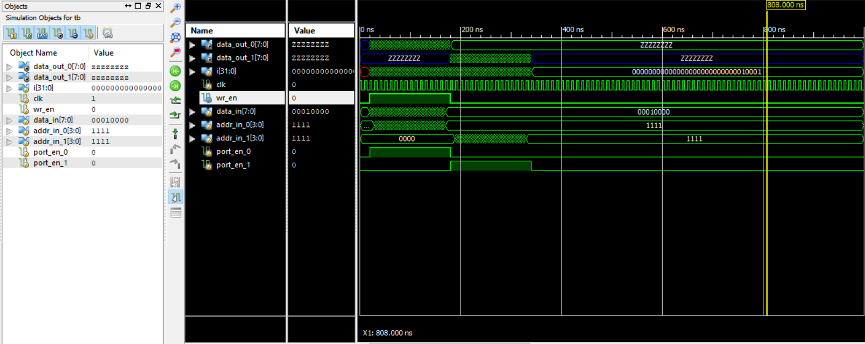

**Serial Input serial output Shift Register code:**

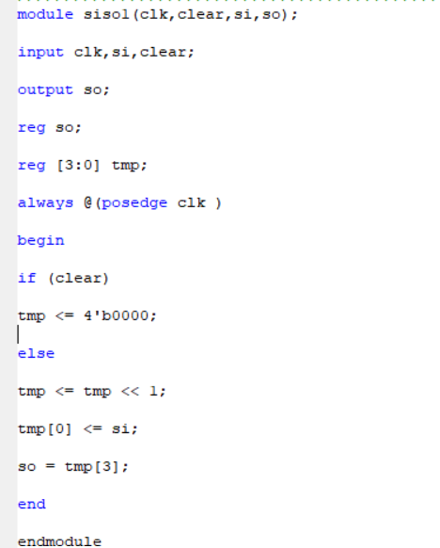

**Test Bench:**

module sisotb;

// Inputs

reg clk;

reg clear;

reg si;

// Outputs

wire so;

// Instantiate the Unit Under Test (UUT)

siso1 uut (

.clk(clk),

.clear(clear),

.si(si),

.so(so)

);

initial begin

clk = 0;

clear = 0;

si = 0;

#5 clear=1'b1;

#5 clear=1'b0;

#10 si=1'b1;

#10 si=1'b0;

#10 si=1'b0;

#10 si=1'b1;

#10 si=1'b0;

#10 si=1'bx;

end

always #5 clk = ~clk;

initial #150 $stop;

endmodule

**RTL Schematics:**

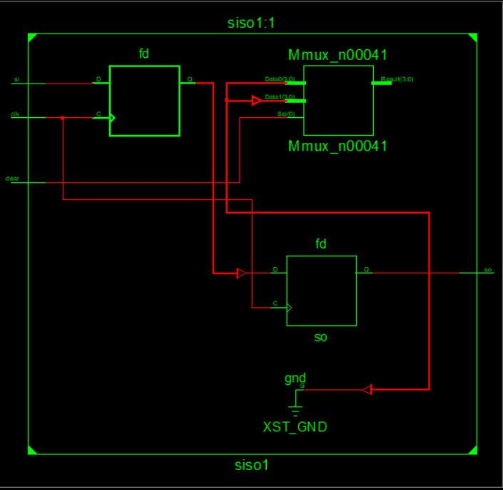

**Tech Schematics:**

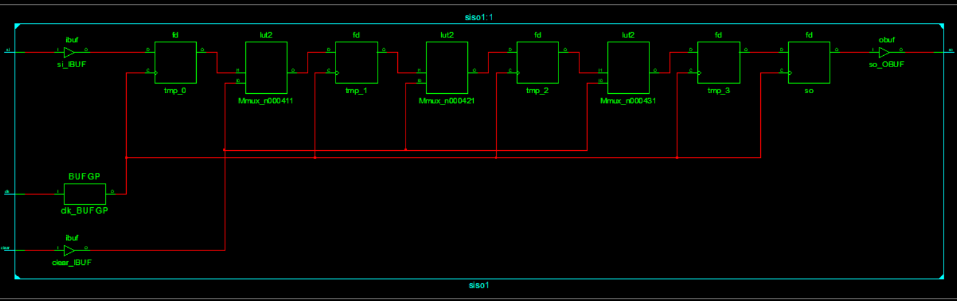

**Graph:** 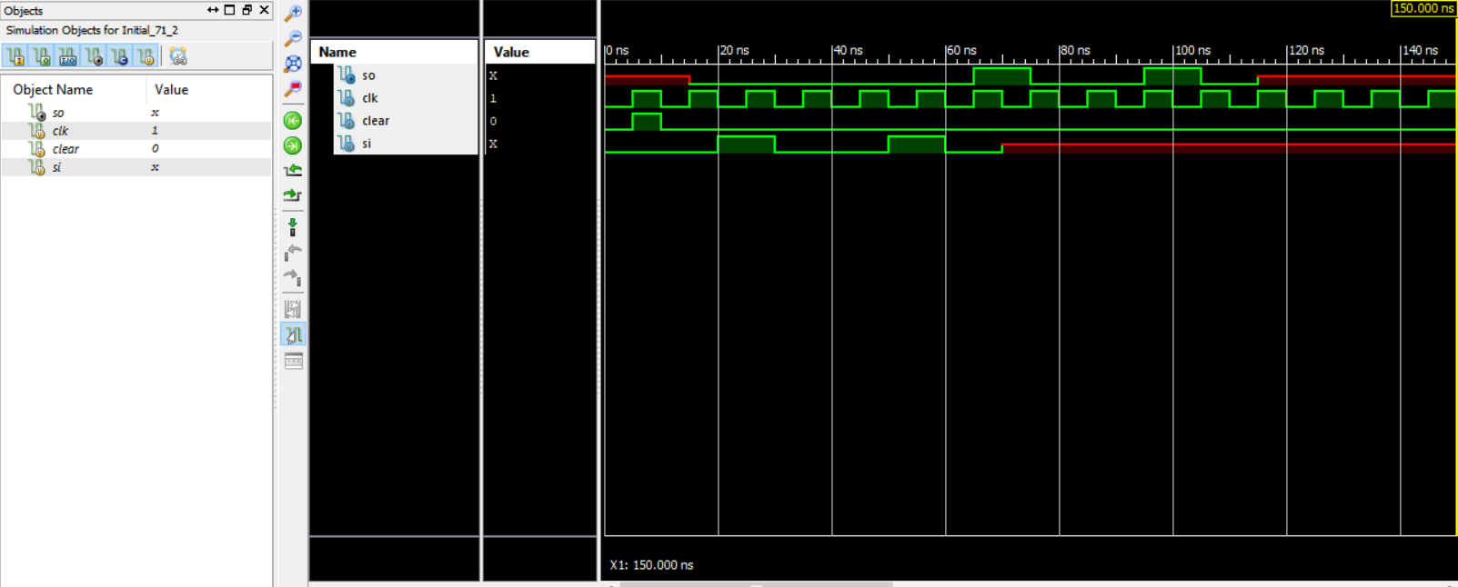

**Parallel in parallel out Shift Register code:**

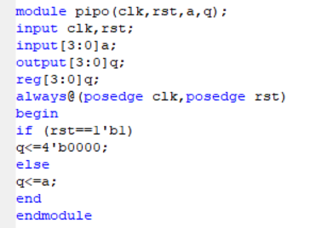

**Test Bench:**

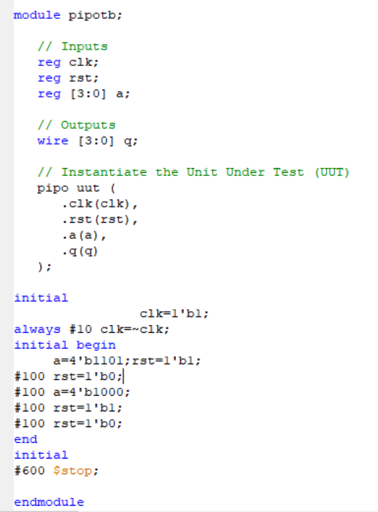

**TECH RTL:**

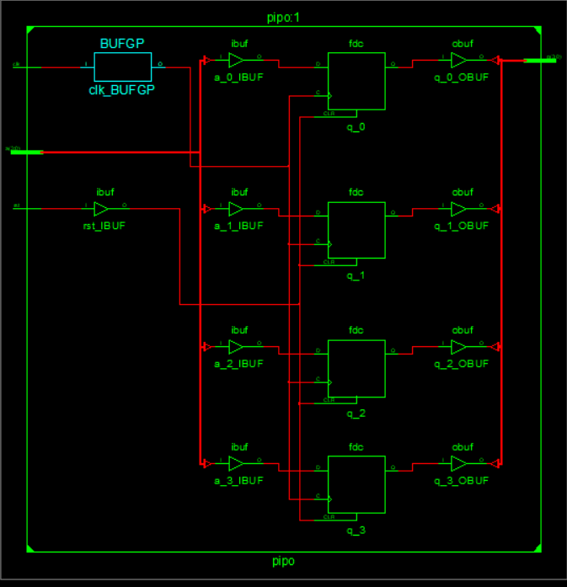

**Graph:** 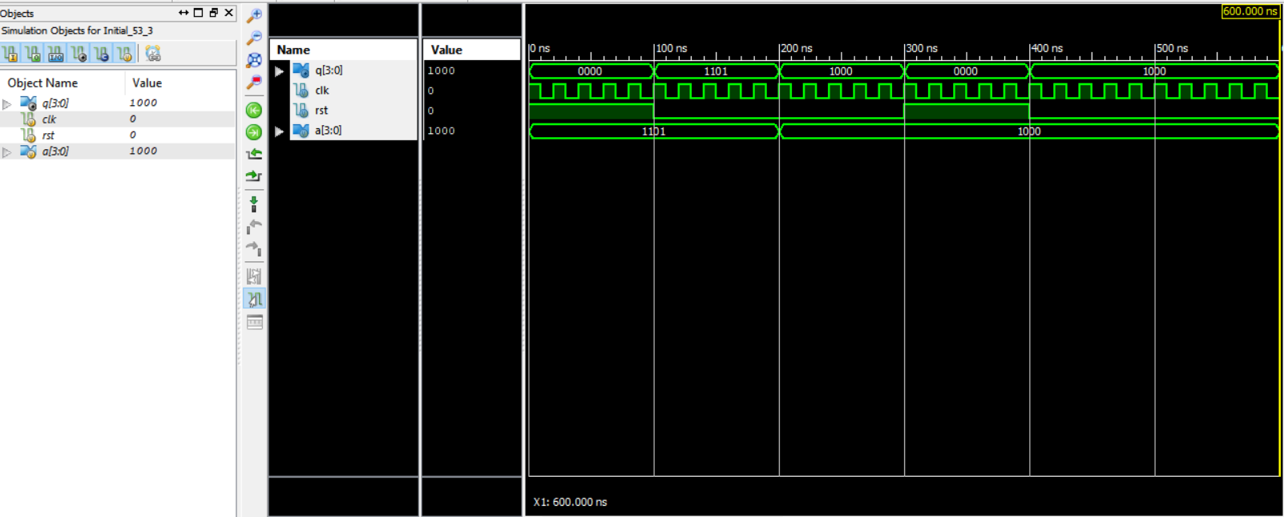

**Serial Input Parallel Output Shift Register code:**

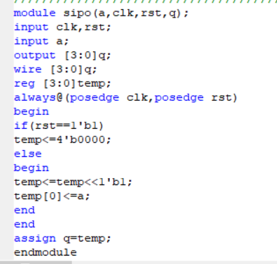

**Test Bench:**

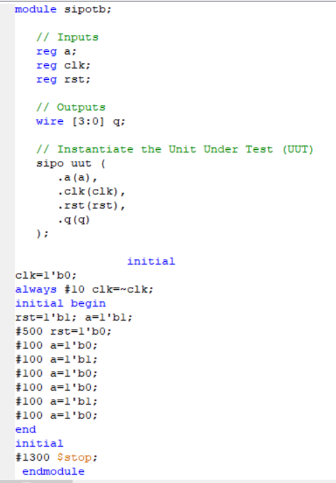

**Tech RTL:**

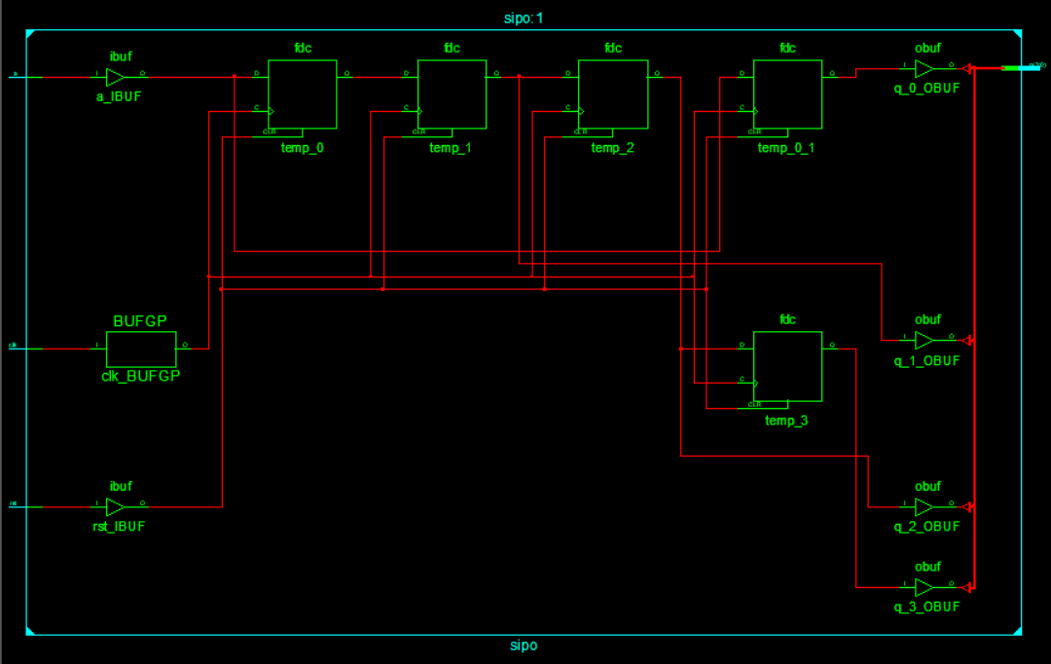

**Graph:** 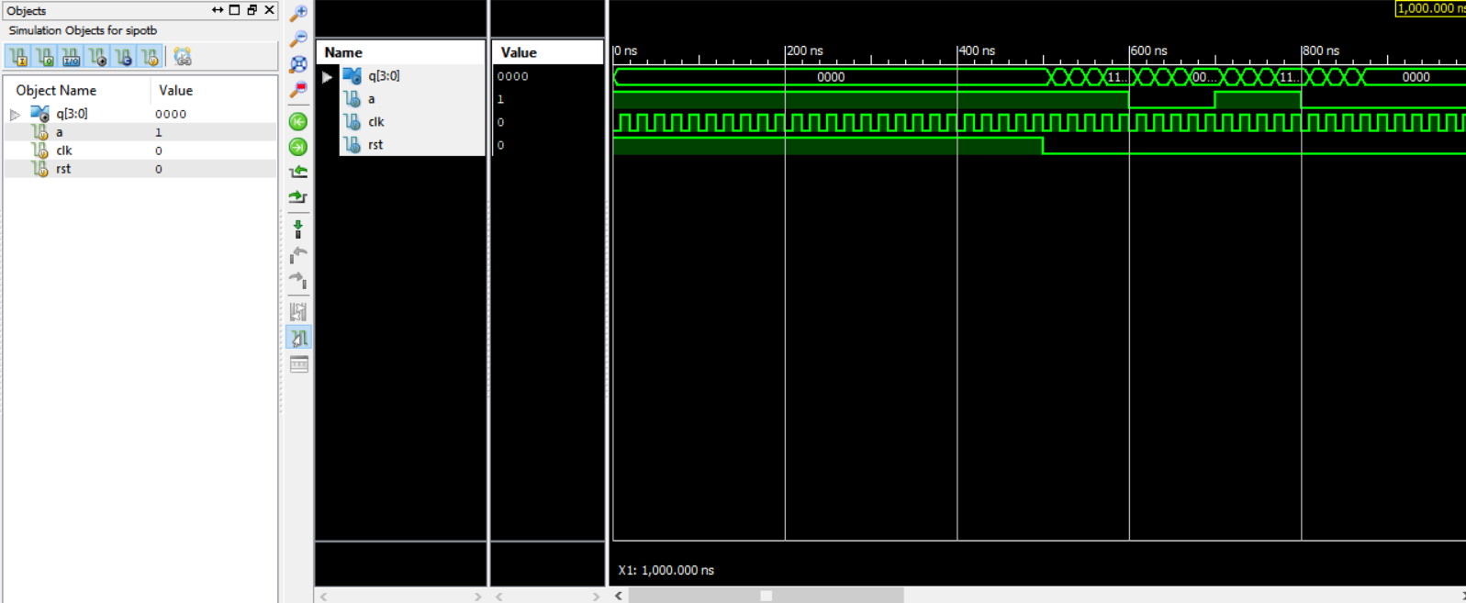

**Parallel Input serial Output:**

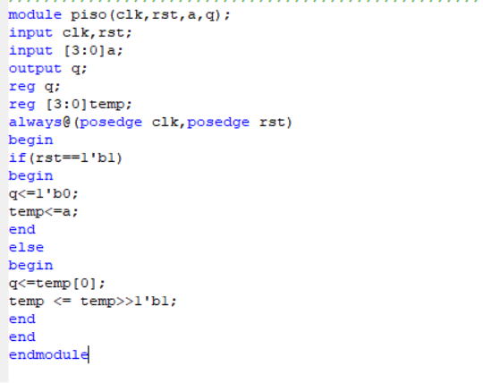

**Test Bench:**

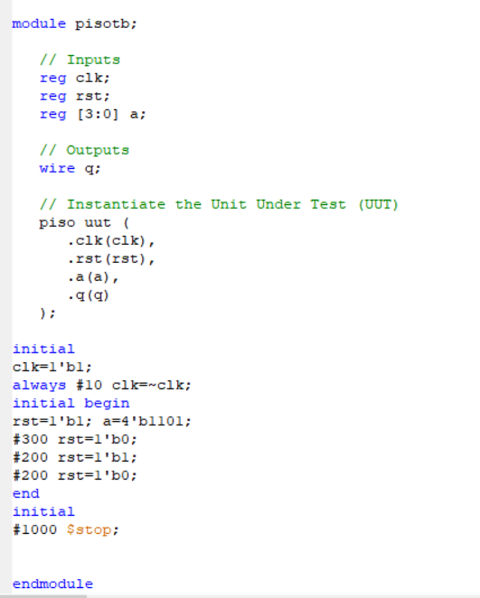

**Tech RTL:**

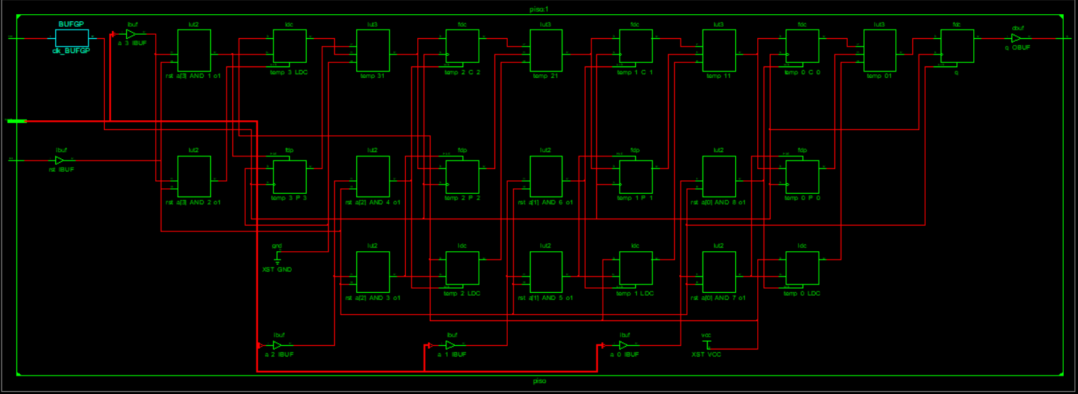

**Graph:** 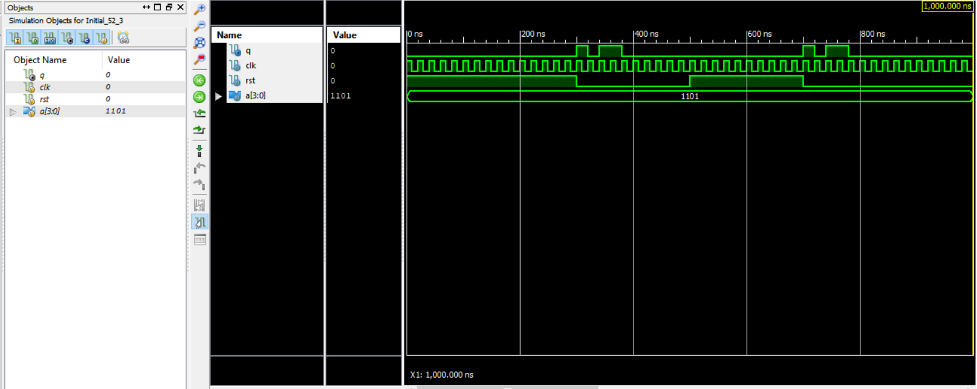

**Working on RAM with Large Input Image Verilog Code:**

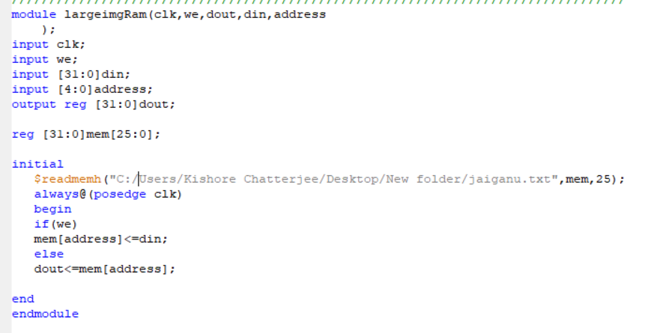

**Test Bench:**

module Gannutb;

// Inputs

reg clk;

reg we;

reg [31:0] din;

reg [4:0] address;

// Outputs

wire [31:0] dout;

// Instantiate the Unit Under Test (UUT)

largeimgRam uut (

.clk(clk),

.we(we),

.dout(dout),

.din(din),

.address(address)

);

initial begin

// Initialize Inputs

clk = 0;

we = 1;

din = 0;

address = 0;

// Wait 100 ns for global reset to finish

#100;

we = 0;

#100 address = 5'd1;

#110 address = 5'd1;

#120 address = 5'd2;

#130 address = 5'd3;

#140 address = 5'd4;

#150 address = 5'd25;

// Add stimulus here

end

always #5 clk = ~clk;

endmodule

**RTL scematics:**

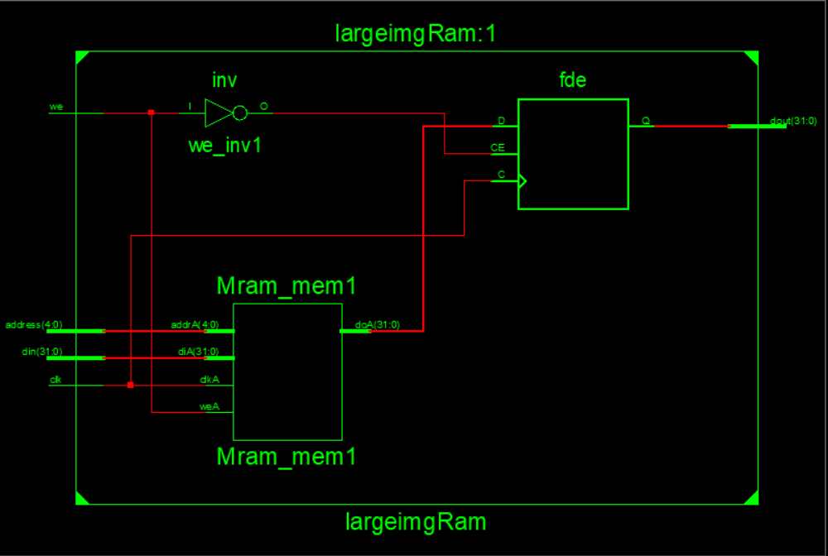

**Technical Schematics:**

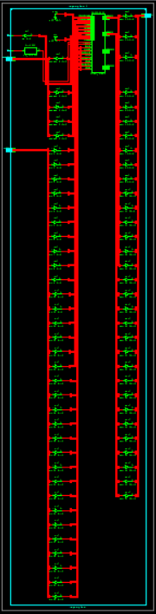

**Graph:** 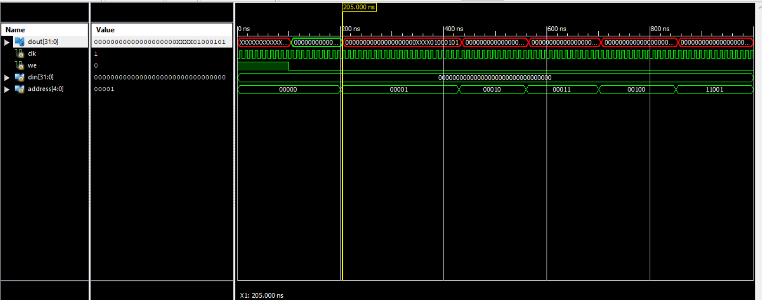

**ALU Verilog code:**

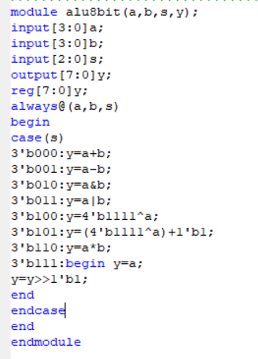

**RTL Schematics:**

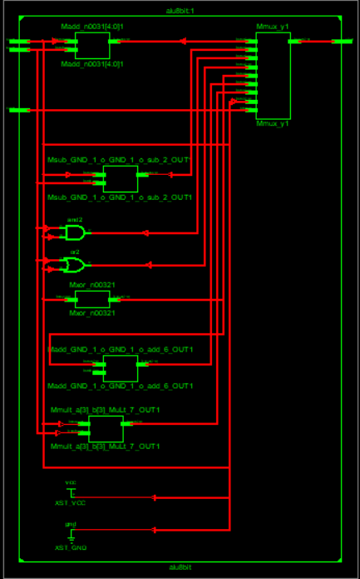

**Technical Schematics:**

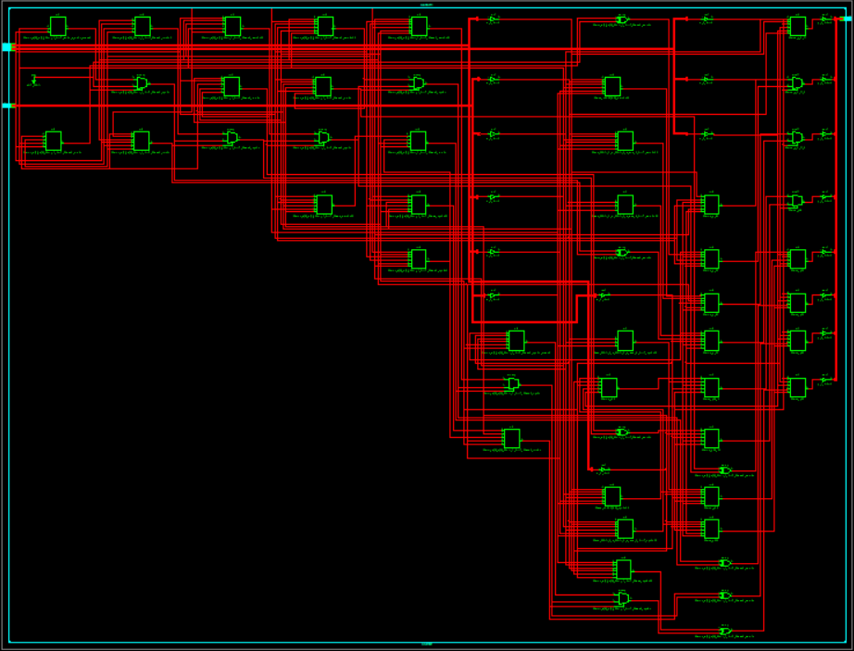

**Graph:**

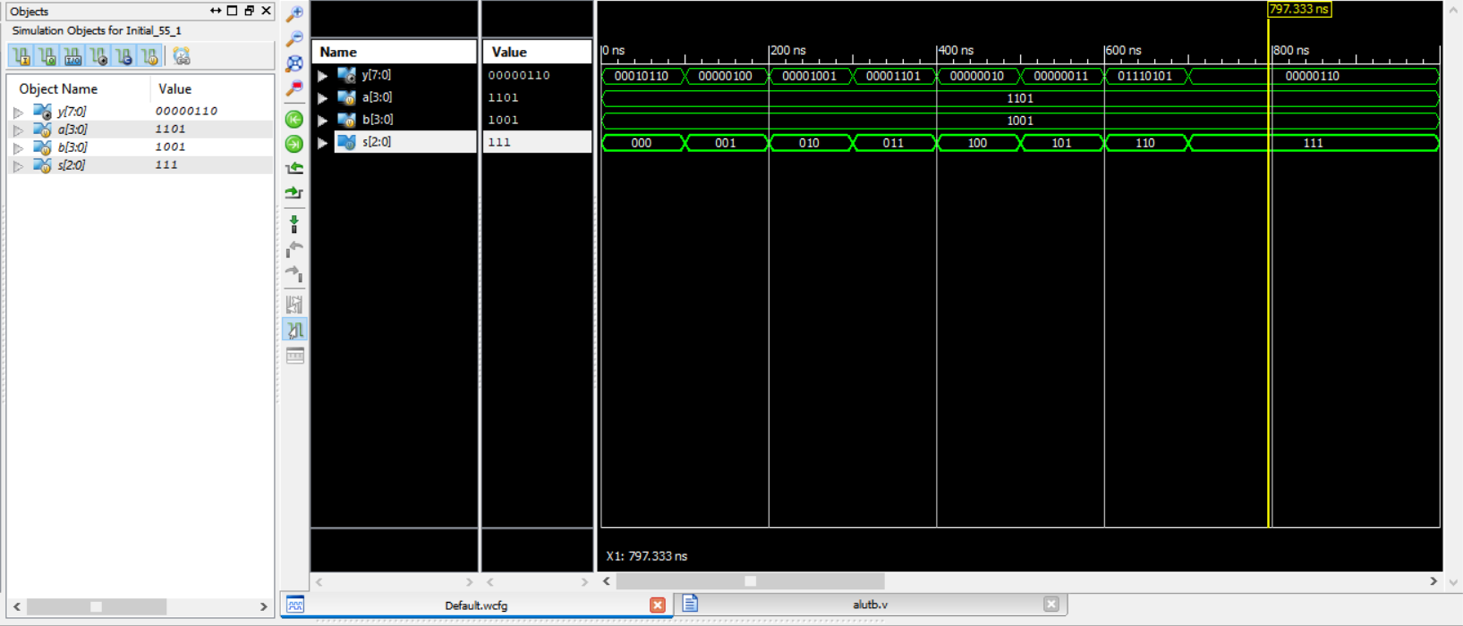

**ALU 16 bit verilog code:**

module alu16bit(

input [7:0] A,B, // ALU 8-bit Inputs

input [3:0] ALU_Sel,// ALU Selection

output [7:0] ALU_Out, // ALU 8-bit Output

output CarryOut // Carry Out Flag

);

reg [7:0] ALU_Result;

wire [8:0] tmp;

assign ALU_Out = ALU_Result; // ALU out

assign tmp = {1'b0,A} + {1'b0,B};

assign CarryOut = tmp[8]; // Carryout flag

always @(*)

begin

case(ALU_Sel)

4'b0000: // Addition

ALU_Result = A + B ;

4'b0001: // Subtraction

ALU_Result = A - B ;

4'b0010: // Multiplication

ALU_Result = A * B;

4'b0011: // Division

ALU_Result = A/B;

4'b0100: // Logical shift left

ALU_Result = A<<1;

4'b0101: // Logical shift right

ALU_Result = A>>1;

4'b0110: // Rotate left

ALU_Result = {A[6:0],A[7]};

4'b0111: // Rotate right

ALU_Result = {A[0],A[7:1]};

4'b1000: // Logical and

ALU_Result = A & B;

4'b1001: // Logical or

ALU_Result = A | B;

4'b1010: // Logical xor

ALU_Result = A ^ B;

4'b1011: // Logical nor

ALU_Result = ~(A | B);

4'b1100: // Logical nand

ALU_Result = ~(A & B);

4'b1101: // Logical xnor

ALU_Result = ~(A ^ B);

4'b1110: // Greater comparison

ALU_Result = (A>B)?8'd1:8'd0 ;

4'b1111: // Equal comparison

ALU_Result = (A==B)?8'd1:8'd0 ;

default: ALU_Result = A + B ;

endcase

end

endmodule

**Test Bench:**

module alu16bittb;

integer i;

// Inputs

reg [7:0] A;

reg [7:0] B;

reg [3:0] ALU_Sel;

// Outputs

wire [7:0] ALU_Out;

wire CarryOut;

// Instantiate the Unit Under Test (UUT)

alu16bit uut (

.A(A),

.B(B),

.ALU_Sel(ALU_Sel),

.ALU_Out(ALU_Out),

.CarryOut(CarryOut)

);

initial begin

// hold reset state for 100 ns.

A = 8'h0A;

B = 4'h02;

ALU_Sel = 4'h0;

for (i=0;i<=15;i=i+1)

begin

ALU_Sel = ALU_Sel + 8'h01;

#10;

end;

A = 8'hF6;

B = 8'h0A;

end

endmodule

**RTL Schematics:**

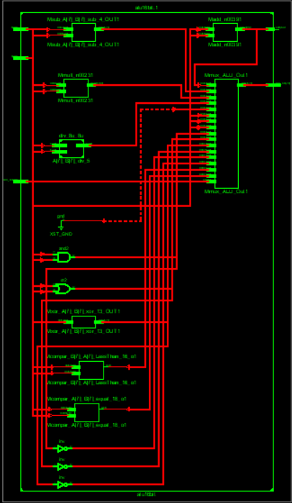

**Techinical schematics:**

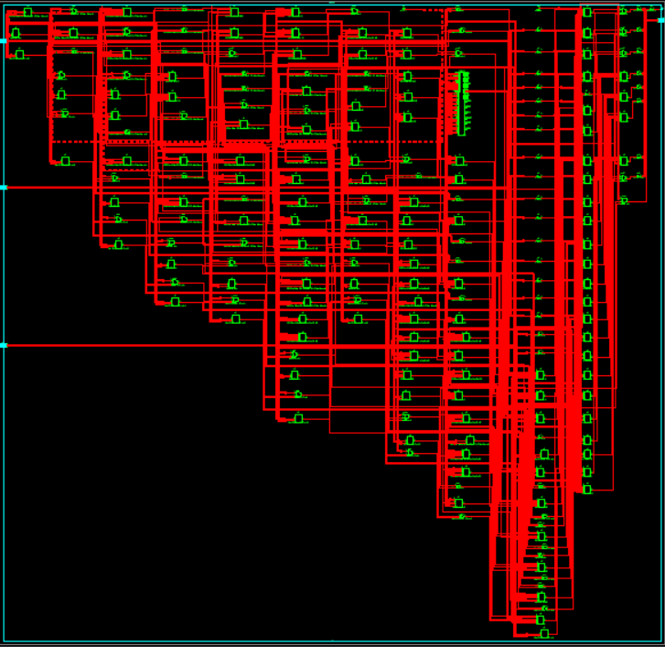

**Graph:**

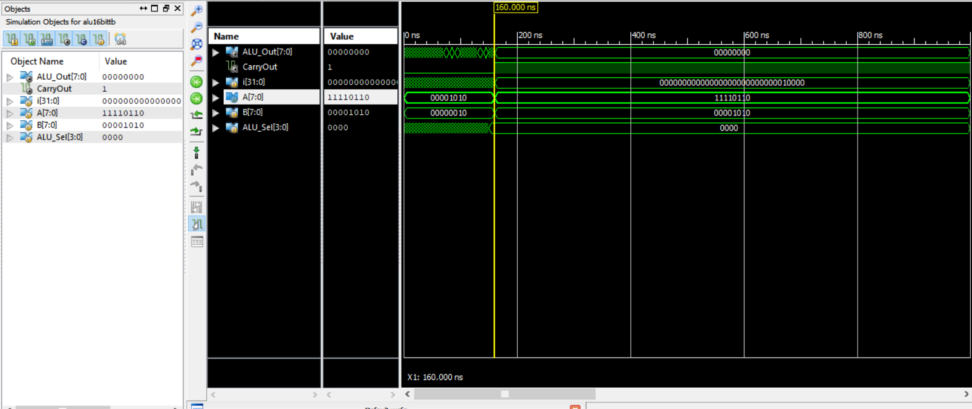

**Counters verilog code:**

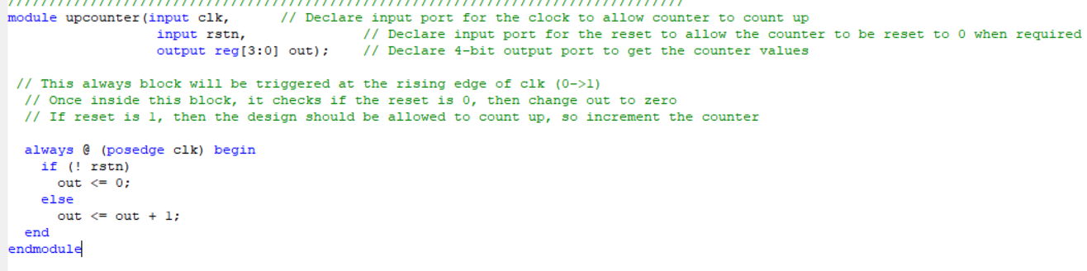

**Test Bench:**

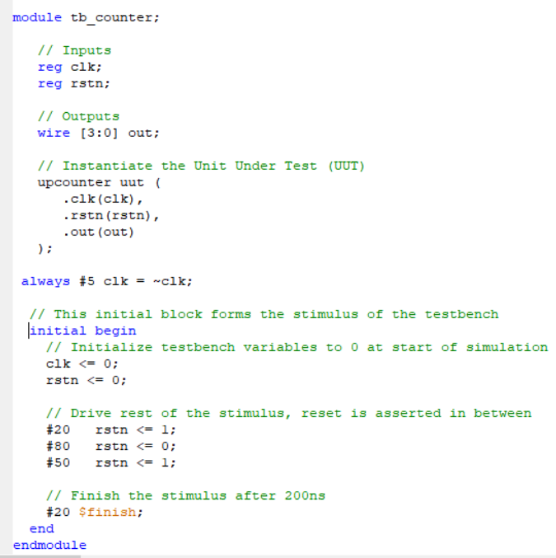

**RTL schematics:**

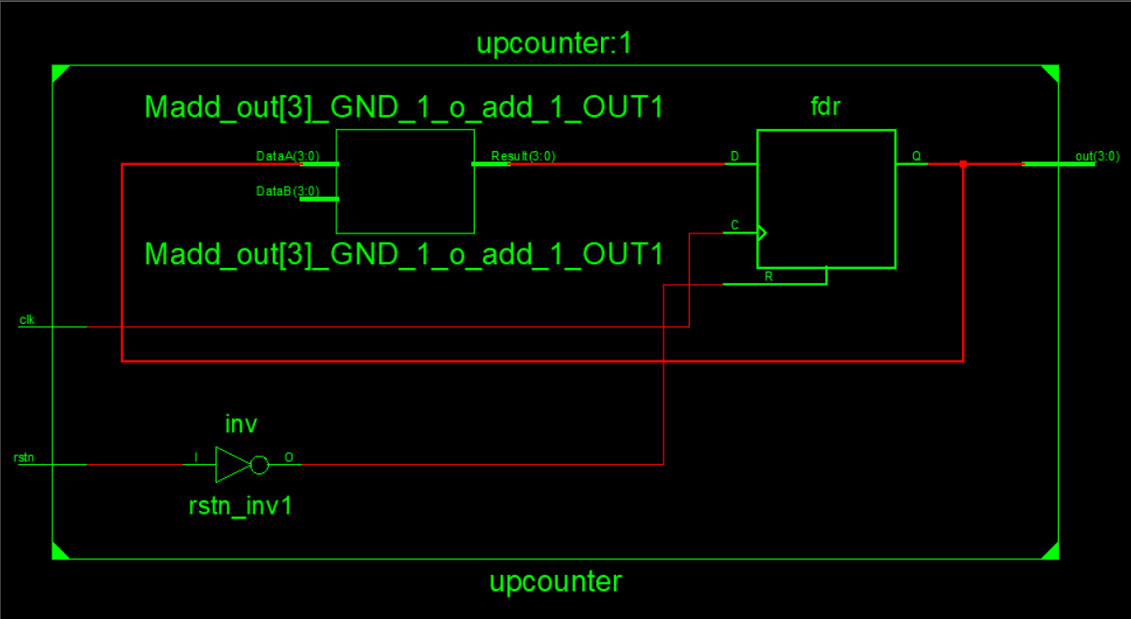

**Technical Schematics:**

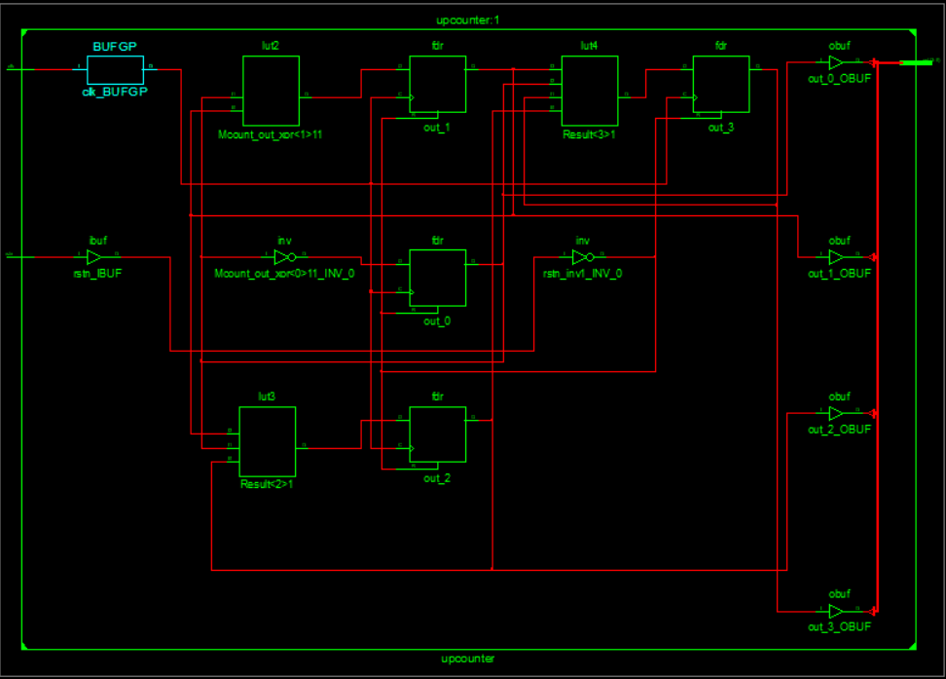

**Graph:** 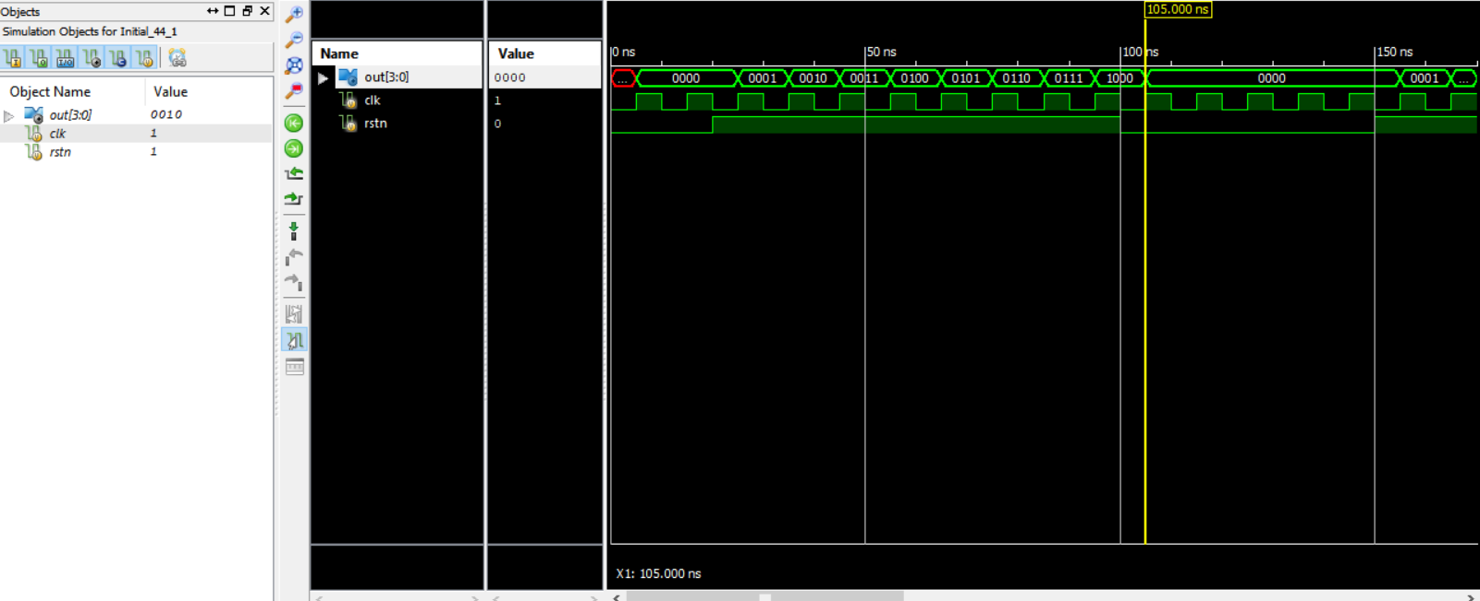

**Mod N_counter verilog:**

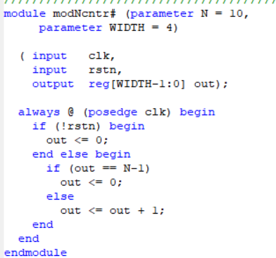

**Test_Bench:**

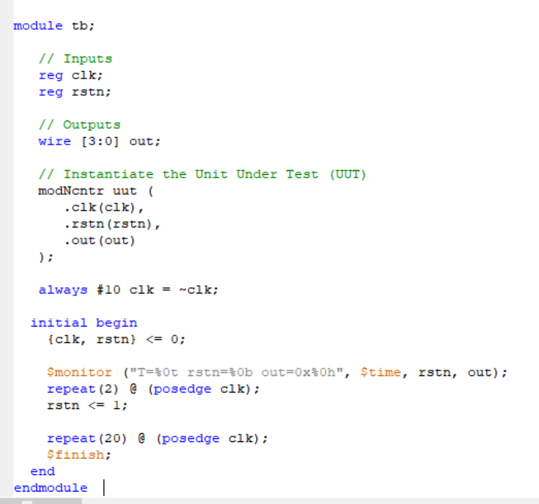

**RTL Schematics:**

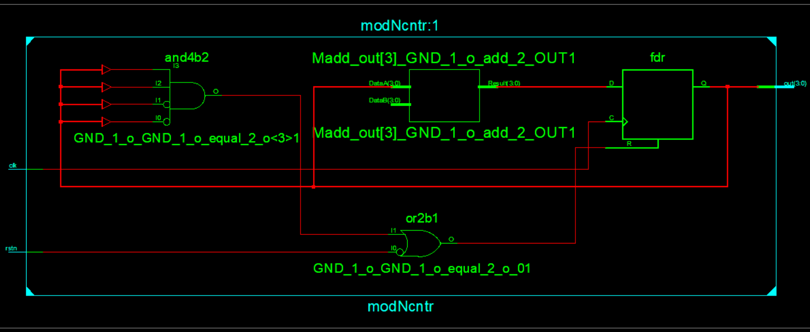

**Technical Schematics:**

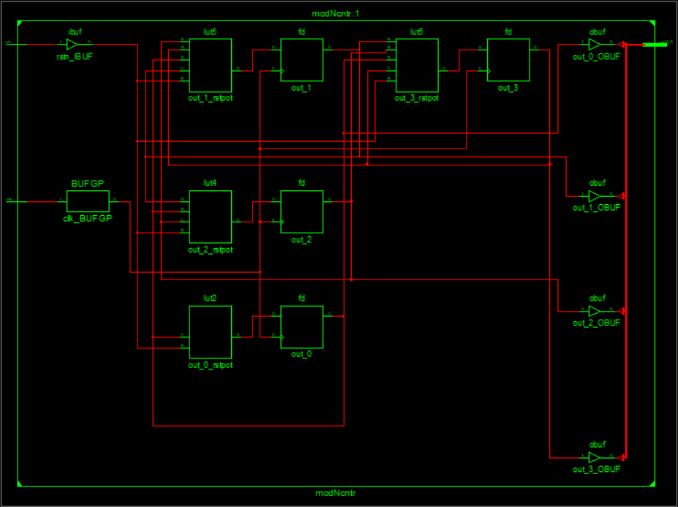

**Graph:** 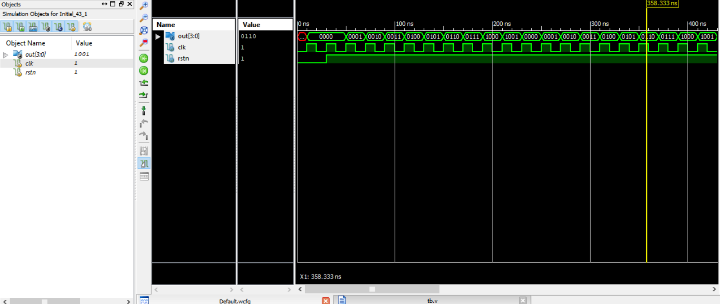

**Up_Down counter Verilog:**

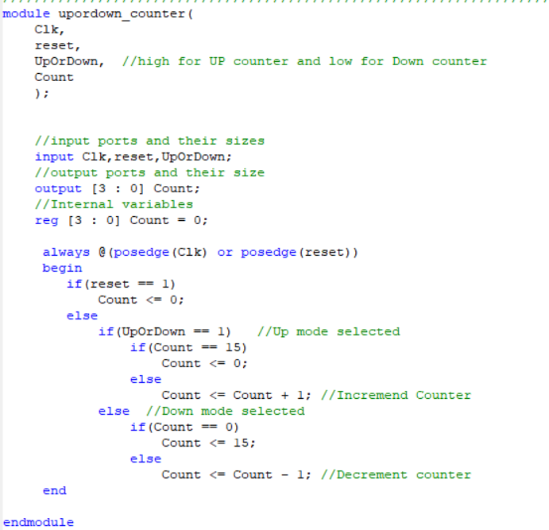

**Test Bench:**

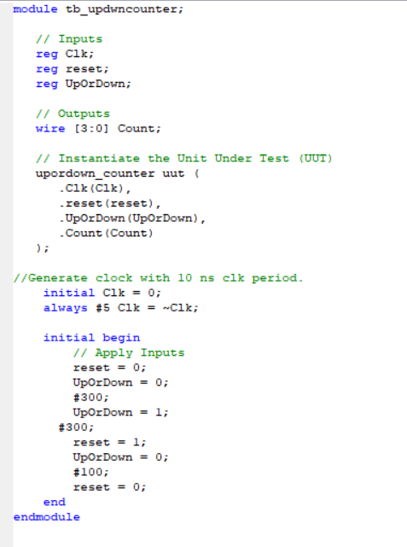

**RTL Schematics:**

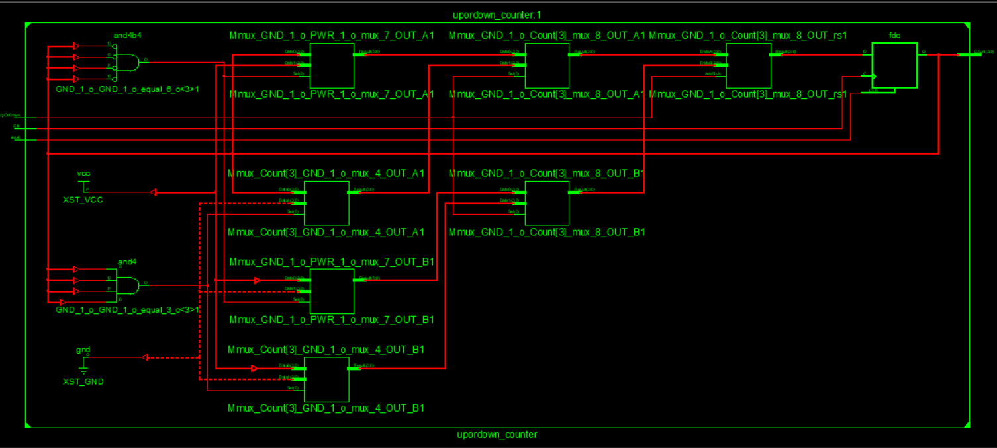

**Graph:** 